Model | ARK20C-W
Name | Wireless programming keyboard
Wireless Frequency | 433MHz
Transmit power | 10dBm
Transmit Distance | 1km（open area/no interference）
Tamper | Unit protection and leaving-wall protection
Installation Way | Portable, wall and 4X2 electricity box installation
Dimensions | 143*82*23 mm(L*W*H)
Weight | 0.25kg
Temperature | -10℃～50℃
Humidity | < 95%
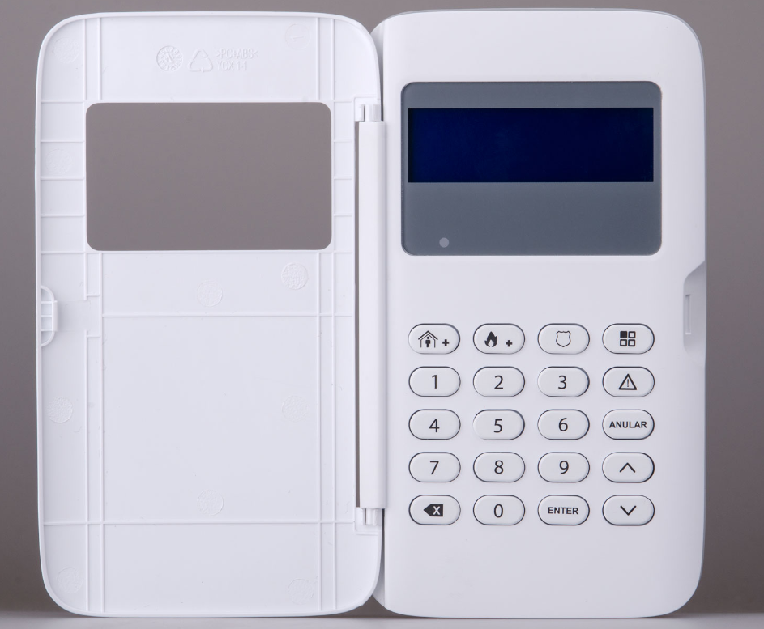
ARK20C-W

