Four Door Access Controller

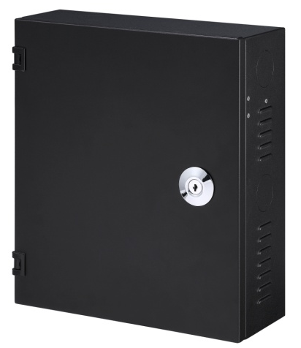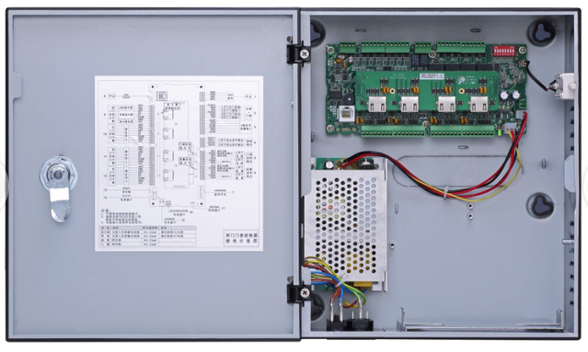
ASC1204C

Features
- Support 100,000 valid cards & 300,000 records
- Support multiple cards
- Support card, password, fingerprint and combination
- TCP/IP or RS-485 interface to PC
- Wiegand or RS-485 interface to readers(2/4 door)
- Door time out alarm, intrusion alarm, duress alarm and tamper alarm
- Anti-pass back, multi-door interlock, multi-card open
- Support 128 efficient time and holiday schedules
- Watch dog function ensure device free from halting
- Surface mounted installation
- Internal battery

Technical Specifications
Model |  |  | ASC1204C
System
Main Processor |  |  | 32 Bit
Memory |  |  | 16M(32M External)
Input/Output Ports
Input |  |  | Inputs x 9 ( door sensor x 4, exit button x 4, alarm x 1)
Output |  |  | Relay x 5(door lock x 4, alarm x 1 )
Reader |  |  | Reader x 4
Capacity
Cardholders/Events |  |  | 100,000/150,000
Function
User Management |  | General, VIP, Guest, Patrol, Black list, Force
Alarm Function |  |  | Door time out alarm, Intrusion alarm, Duress alarm, Tamper alarm
Schedule Setting |  |  | Support 128 groups of schedule, 128 groups of period and 128 groups of holiday period
Interface
To PC | RJ45(10/100M)/RS485
To Reader | Wiegand/ RS485
Genreal
RTC |  |  | Yes
Ingress protection |  |  | IP55
Power Supply |  |  | 9-15DC/500mA
Internal Battery |  |  | 1204C Support
Working Environment |  |  | -30℃-+60℃
Working Humidity |  |  | ≤95%
Dimension(W×D×H) |  |  | 280*320*114mm
Weight |  |  | 2Kg

System Connection
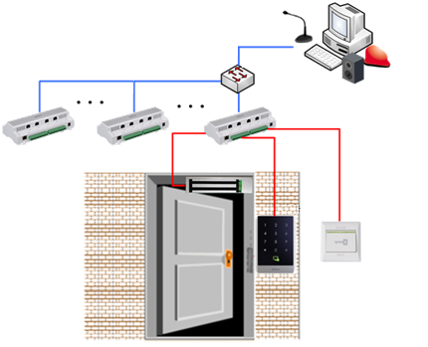

Dahua Technology Co., Ltd.
1187 BinAn Road, Binjiang District, Hangzhou, China
Tel: +86-571-87688883
Fax: +86-571-87688815
Email: overseas@dahuatech.com
www.dahuatech.com
*Design and specifications are subject to change without notice.
© 2015 Dahua Technology Co., Ltd.

