All-in One Flow Analytics Camera
User’s Manual

Version 1.0.1
Models
Unit Model | Camera Model | Pixels
CP235-TU1A | ITC235-TF1A | 2.3 MP
CP235-TU1A-H | ITC235-TF1A | 2.3 MP
CP235-TU1A-L | ITC235-TF1A | 2.3 MP
CP235-TU1A-HL | ITC235-TF1A | 2.3 MP

Important Safeguards and Warnings
Please read the following safeguards and warnings carefully before using the product in order to avoid damages and losses.
Note:
- Do not expose the device to lampblack, steam or dust. Otherwise it may cause fire or electric shock.
Do not install the device at position exposed to sunlight or in high temperature. Temperature rise in device may cause fire.
Do not expose the device to humid environment. Otherwise it may cause fire.
- The device must be installed on solid and flat surface in order to guarantee safety under load and earthquake. Otherwise, it may cause device to fall off or turnover.
Do not place the device on carpet or quilt.
Do not block air vent of the device or ventilation around the device. Otherwise, temperature in device will rise and may cause fire.
Do not place any object on the device.
Do not disassemble the device without professional instruction.

Warning:
Please use battery properly to avoid fire, explosion and other dangers.
Please replace used battery with battery of the same type.
- Do not use power line other than the one specified. Please use it properly. Otherwise, it may cause fire or electric shock.

Special Announcement
- This manual is for reference only.
- All the designs and software here are subject to change without prior written notice.
-  All trademarks and registered trademarks are the properties of their respective owners.
- If there is any uncertainty or controversy, please refer to the final explanation of us.
 Please visit our website for more information.

Table of Contents
1 Product Introduction 1
1.1 Overview 1
1.2 Features 1
1.3 Function 1
2 Device Structure 4
2.1 Appearance 4
2.2 Terminal 4
2.3 Camera 5
2.3.1 Rear Panel 5
2.3.2 Side Panel 7
2.3.3 Front Panel 7
3 Device Installation 9
3.1 Install Camera 9
3.1.1 Install Lens 9
3.1.2 SD Card Installation 10
3.2 Install Cable 11
3.2.1 Install Cable 12
3.2.2 Remove Cable 12
3.3 Connect Lightning Arrester 12
3.4 Install Sun Shade 13
3.5 Install Bellows 13
4 System Network 14
5 Access Device 15
5.1 Network Connection 15
5.2 Login WEB 15
Appendix 1 FAQ 18
Appendix 2 Quick Config Tool 19

Product Introduction

Overview
All-in-One Flow Analytics Camera installs camera into housing, and increasing network lightning arrester, terminal in the housing, improve the degree of standardization system, eliminating the need for on-site installation of the engineering business processes, save a lot of time.
This product integrates image/video data capture, management, using advanced processing chips and sensors, and captures different road monitoring scenes. It transmits video data to client, server, backstage storage device via network for unified management.

Features
Structure
- All embedded, integrated and modularization
- Complete low consumption integrated structural design.

Highly Integrated
- Built-in camera, fill light, network lightning arrester, terminal and etc. which greatly reduce on-site installation time and lower fault of camera.

High Performance
- High performance TI multi-core processer.
- High performance CMOS image sensor, high color reproduction, high light sensitivity.
- High performance ISP.

Abundant Interface
- Abundant signal, data and COM interfaces.
- Precise sync signal input and output control.

Application
- Widely applied in city road traffic surveillance system, high way road surveillance system, residence surveillance and etc.

Function
Cutout
Cut out part of vehicle plate or driver’ face in snapshot.

Intelligent Recognition
- Recognition of plate, vehicle logo, vehicle series, vehicle body color and vehicle model.
- Detection of crossing line, wrong-way driving, over speed and etc.

User Management
- Config multiple user groups and users. Each user group and user can he set with different rights.
- Search of online user.
Log Management
- Up to 1024 log records storage.
- User right control.

Storage
- Support record via Web and the recorded file are storage in the client-end PC.
- Support local SD card, hot swap, support short-time storage when encounter disconnection. When storage space is insufficient, it will auto overwrite picture stored.

Alarm
- Abnormal operation of the camera alarm via the network center, such as memory damage.
- Via device alarm input terminal connect to various alarm peripherals, real-time response within 200ms of external alarm input on a variety of alarm information can be correctly processed according to pre-defined set user interaction and can give corresponding audio prompt.

Network Monitoring
- Through the network, transmit single channel video data compressed by the device to the network terminal for decompression and reproduction. In the case of bandwidth allows delay within 500ms.
- The device supports a maximum number of 10 online users.
- Video data transmission use HTTP, TCP, UDP, MULTICAST, RTP / RTCP and so on.
- Support systems web access mode, used in a WAN environment.

Vehicle Flow
- Matching with traffic signal controller, output vehicle in signal and out signal.
- Within set period, support statistics of flow, time occupancy, head distance, line length and etc.

Snapshot
- Support picture snapshot and encode. Support watermark encryption to avoid the vicious modification.
- Snapshot can auto record vehicle info such as time.

OSD Setup
Set video channel, picture and combine picture OSD info and position.

Network Management
- Manage device config and control right via Ethernet.
- Manage device via WEB.

Peripheral
- Support peripheral control function, may freely set control protocol and connection interface of each peripheral.
- Connect to flashlight, strobe, vehicle detector, signal detector, radar and others to trigger peripheral.

Power Supply
Support AC sync function, support DC 12C.

White Balance
- Auto White Balance: when the light changes, the color is still able to accurately reflect the status of the subject.
- Local White Balance: Referring to the surrounding environment, adjust the color of the subject case.

Auto Exposure
The exposure value of monitored image can be measured by light system, and according to the factory-set shutter and aperture combination of exposure, the shutter speed is automatically set.

Auto Gain
Low luminance camera automatically increases sensitivity, enhanced image signal output to obtain a clear and bright image.

AUX Function
- Support video encoding watermarking technology to prevent the video image been tampered.
- Support resource information system running and real-time display, support log function.
- Support flash exposure signal control and the output.

Device Structure

Appearance
This camera has the following structure. Device housing includes power, lightning arrester, fan, heater, terminal, fill light, camera and etc.
See Figure 2- 1.
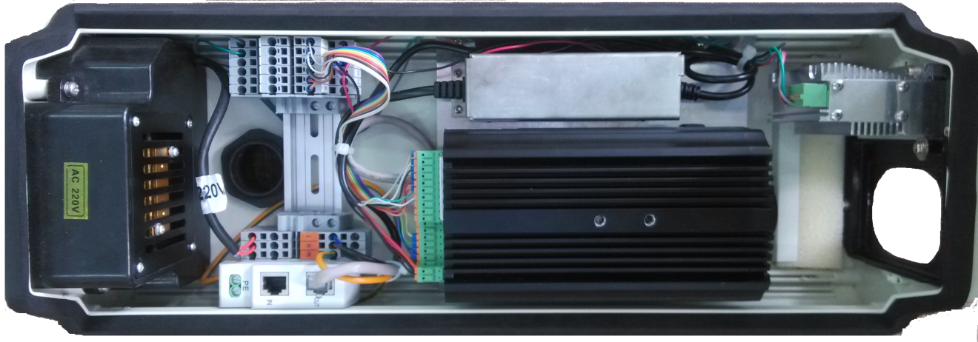
Figure 2- 1

Terminal
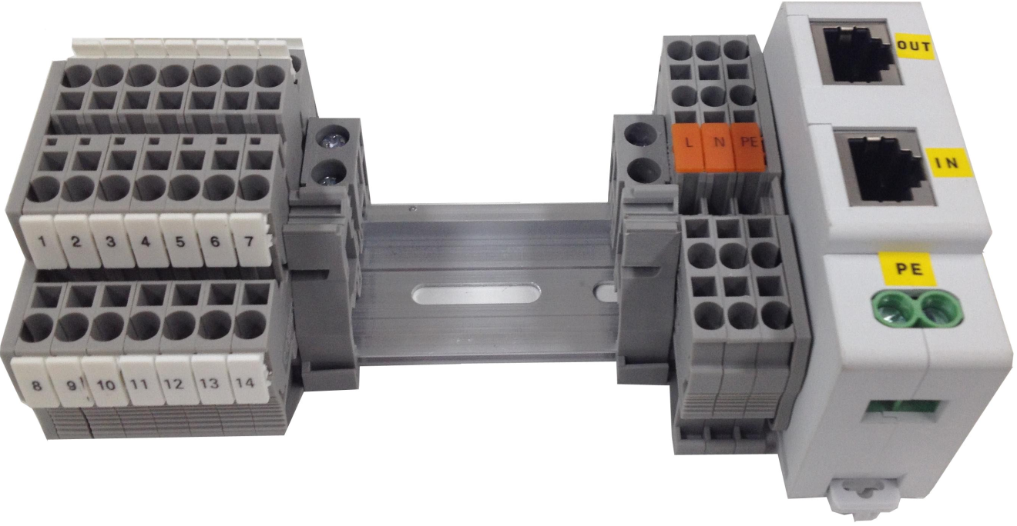
Figure 2- 2
Pin and No. | Function
1 | Flashlight 1 trigger output F1+
2 | Flashlight 1 trigger output F1-
3 | Flashlight 2 trigger output F2+
4 | Flashlight 2 trigger output F2-
5 | Flashlight 3 trigger output F3+
6 | Flashlight 3 trigger output F3-
7 | Flashlight 4 trigger output F4+
8 | Flashlight 4 trigger output F4-
9 | Flashlight 5 trigger output F5+
10 | Flashlight 5 trigger output F5-
11 | Strobe light sync output F7+
12 | Strobe light sync output F7-
13 | RS485-A1
14 | RS485-B1
L | AC220V power, firing line
N | AC220V power, null line
PE | AC220V power, GND

Camera

Rear Panel
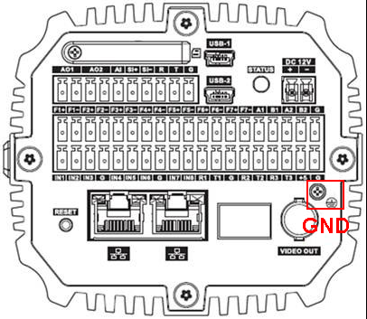
Figure 2- 3
Interface Name |  | Function
SD | SD card port | SD card connection. SD card use:  - When install SD card, make sure SD card is not write-protected status and then inserted into the SD card slot.  - When remove the SD card, make sure the SD card is a non-write state, otherwise it may cause data loss and SD card damage.  - When hot-swap SD card, stop recording after the operation.
AO1, AO2 | 2-ch alarm output | It can be configured as alarm output interface and output interface wipers
AI | Alarm input port | Alarm input interface for receiving external alarm switch signal sources.
SI+, SI- | External frequency source sync input port | Camera Sync external signal source (select external sync option automatically take effect, voltage  Range 12 ~ 36Vp-p or AC 12V ~ AC 24V).
R | RS232 port | RS232_RX .RS232 receive end
T | RS232 port | RS232_TX. RS232 send end.
G | GND | RS232 ground end
STATUS | Status indication light | It is to indicate camera working status:  - The red light becomes on when connect the camera to the power. The blue light flashes and then becomes on, which means application is running normally. Now you can log in via network.  - The indication light becomes off when you reboot the system.  - The blue light flashes when recording.  - The red light flashes when system is upgrading.  - The red light flashes in safety mode.
RESET | RESET button | - Restore factory default setup.  - When system is running normally (power indication light is blue), press the RESET button for at least 5 seconds, system can restore factory default setup.
DC 12V | - | - Input DC 12V.
F1+, F1-, F2+, F2-, F3+, F3-, F4+, F4-, F5+, F5-, F6+, F6- , F7+, F7- | 7-ch output ports | On/off, may allocate separately flashlight output signal and strobe light output signal.
A1 | RS485 port | RS485_A1 port. It is to connect to vehicle detector and etc.
B1 | RS485 port | RS485_B1 port. It is to connect to vehicle detector and etc.
A2 | RS485 port | RS485_A2 port. It is to connect to vehicle detector and etc.
B2 | RS485 port | RS485_B2 port. It is to connect to vehicle detector and etc.
IN1, IN2, IN3,I N4, IN5, IN6, IN7, IN8 | IO input port | Provide 8 IP trigger snapshot ports
R1 T1 G  R2 T2 G  R3 T3 G | 3-ch radar port | Reserved.
+5 | - | Power supply to small power 2W device.
USB1/USB2 | 2 USB ports | Used to expand 3G and WIFI
 | 2 network ports | Connect to standard Ethernet cable.
VIDEO OUT | Video output BNC | BNC (1.0Vp-p, 75Ω).
 | GND | You must ground this interface, in order to avoid being struck by lightning and other device problems.

Side Panel
Side panel dimensions are =170.5mm×96mm×85mm.(L*W*H) Unit is mm.
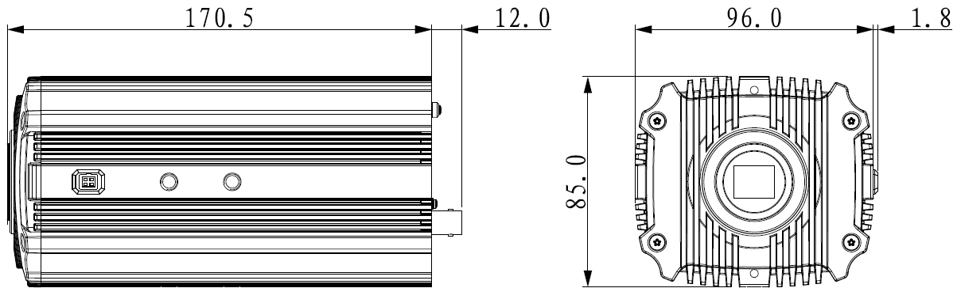
Figure 2- 4

Front Panel
Unit is mm.
Figure 2- 5

Device Installation
Note:
When you open the device, please refer to checklist of accessories. Check whether any accessory is missing. Then please install the device following instructions in this chapter.
You will need install lens, SD card, cable, sun shade and etc. Other accessories and cables shall be installed accordingly.

Install Camera

Install Lens

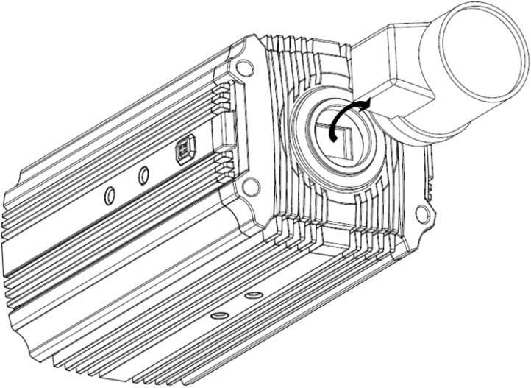
Figure 3- 1

Install Auto Iris Lens
- Remove the CMOS protective cover on the device. Aim the lens at the mounting position of the lens on the camera, rotate the lens clockwise until it is securely in place.
- Insert the plug of the lens cable to the auto iris lens connector on the side panel of the camera.
- Adjust the focus so that the image is clear.

Install Manual Iris Lens
Install Type C manual iris lens:

- First remove the cover on the CMOS protective device. Use cross screwdriver to unfasten screw next to focusing ring, aim the lens at the mounting position of the lens on the camera, rotate the lens clockwise until it is securely in place.
- Counterclockwise rotate the focusing ring and manually focusing.
- Use cross screwdriver to fasten screw, fixing focusing ring.

Remove Lens
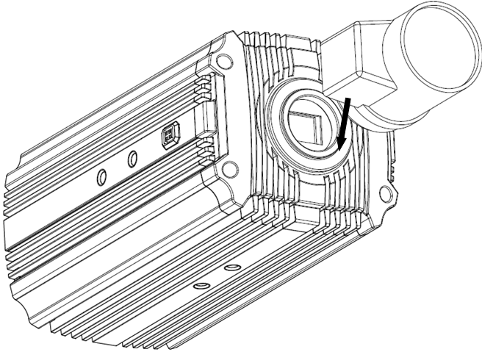
Figure 3- 2
- Turn the lens counter clockwise and then remove it from the camera.
- Unplug the auto lens cable socket from the auto lens connector. If you are using the manual aperture lens, please skip to the following step.
- If there is no lens, please put the CMOS protection cap back to protect the CMOS.

SD Card Installation

Installation
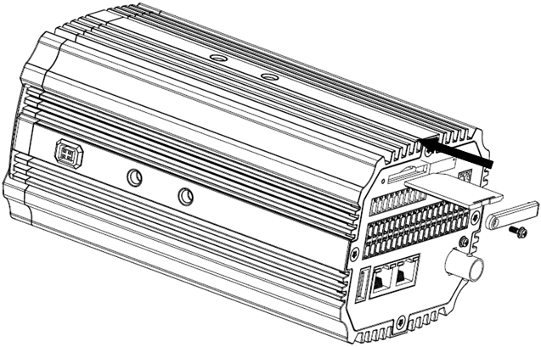
Figure 3- 3

- Use the screwdriver to loosen the SD card protection screw in the rear panel, and then remove the SD card protection cap from the camera.
- Install the SD card into the camera according to the proper installation position.
- Put the SD card protection cap back.
- Use the screwdriver to fix the SD card protection cap screw firmly to secure the SD card protection cap in the camera.

Remove SD card
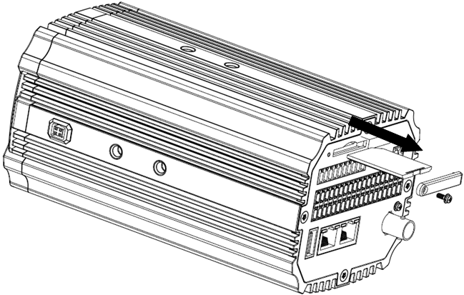
Figure 3- 4
- Use the screwdriver to loosen the screw of SD card protection cap in the rear panel. Remove the cap from the camera.
- Follow the SD card direction to remove the SD card from the device.
- Insert the SD card protection cap.
- Use the screwdriver to fix the screw to secure the protection cap.

Install Cable
Warning:
- When connecting the power cord, avoid bare copper wire. Because the power supply is 220V, once bare copper wire leakage phenomenon occurs, it will result in personal injury.
- When removing the cable, turn the device off before operation, in order to avoid leakage causing personal injury.
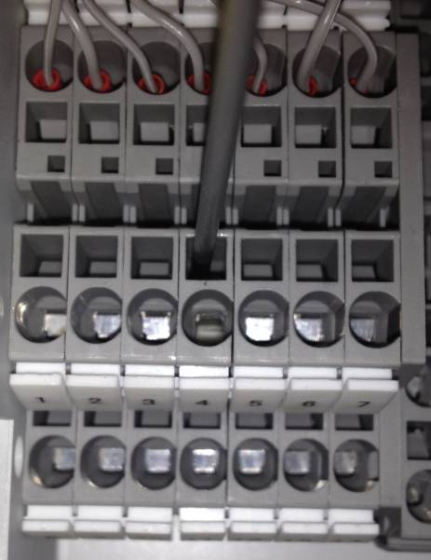
Figure 3- 5
- To ensure the device is properly grounded, improve device reliability, please note: ① confirmed the shield PE terminal device supporting the use of the interface is connected; ② the shield and PE port should be connected to ground. Pictures are for reference only, actual cables shall prevail.
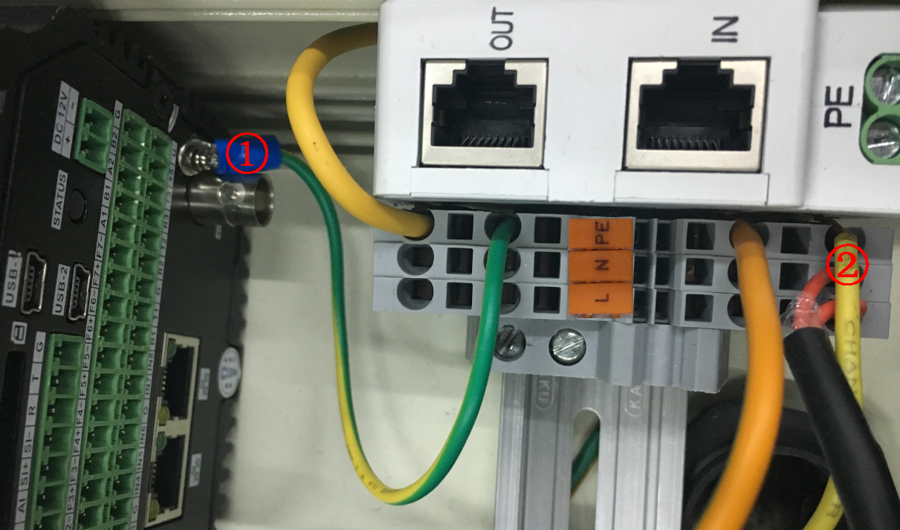
Figure 3- 6
Preparation
Straight screwdriver with screw head width of 2mm.

Install Cable
- Insert the small slotted screwdriver into corresponding square slot of connection cable, vertically press screwdriver, to exposure metal piece in circular slot.
- Insert cable into circular slot.
- Draw out screwdriver in square slot.

Remove Cable
- Insert the small slotted screwdriver into corresponding square slot of connection cable, vertically press screwdriver, to exposure metal piece in circular slot.
- Draw out cable from circular slot.
- Draw out screwdriver in square slot.

Connect Lightning Arrester
To guarantee normal operation of light arrester, please connect its port “IN” to the Internet, and connect port “OUT” to the camera.
Note:
By default, “OUT” port has been connected to camera, see figure below.

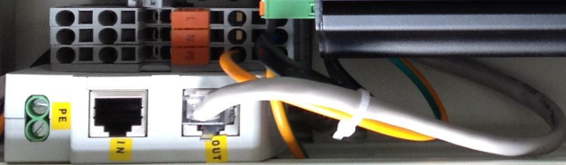
Figure 3- 7

Install Sun Shade
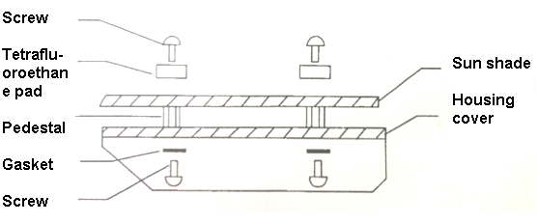
Figure 3- 8
- Remove screw on housing.
- Fix pedestal on housing cover.
- Aim sun shade at center hole of pedestal, and fix sun shade with screw.

Install Bellows
Bellows protect the cable.
- Pull the cable into bellows.
- Thread the cable into the device through hole at the bottom of the device.
- After threading is complete, insert bellows into the hole and fix it.

System Network
This series of products as the core of the road monitoring system of video surveillance, the device can monitor different ways to record, and the centralize management of video data by transmitting video data over the network to the controller, or transmitting them to a central control unit, the back-end storage devices. Please refer to Figure 4- 1 for system connection.
Video Detector
Flashlight
Client
Storage Device
…

…

All-in-One Flow Analytics Camera
Central Server
Figure 4- 1

Access Device

Network Connection
After device installation is complete, plug the device to power of AC 220V.
For example a device and PC are directly connected, the following is operation of connection. IP address and other info shall subject to actual condition.
- Use Ethernet cable to connect PC and device.
  - One end of Ethernet cable connects PC port, and the other end connects to the device port.
  - PC and the device IP shall be in the same network segment. When segment is 192.168.1.X, do not overlay with default IP address of 192.168.1.108.
  - Use order ping ***.***.***.***(device IP address) to check connection is OK or not.
- Refer to Quick Config Tool chapter for device login and IP modification.
- Separately connect Ethernet ports of PC and the device to the network.

Login WEB
- Open IE and input HD intelligent traffic camera address in the address bar.
For example, if your camera IP is 192.168.1.108, then please input http:// 192.168.1.108 in IE address bar. See Figure 5- 1.

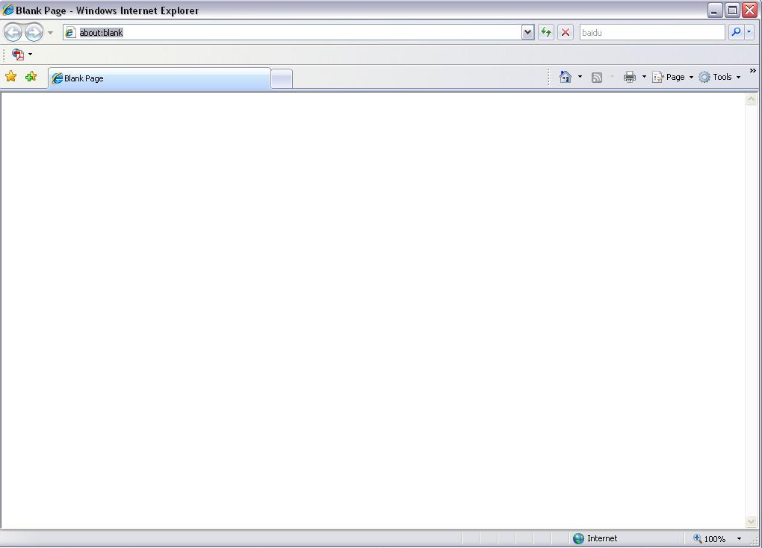
Input your IP address here
Figure 5- 1
- Select ACCEPT.
System pops up warning information to ask you whether install control webrec.cab or not. Please click OK button, system can automatically install the control. When system is upgrading, it can overwrite the previous Web too.
If you can’t download the ActiveX file, please check whether you have installed the plug-in to disable the control download. Or you can lower the IE security level. See Figure 5- 2.
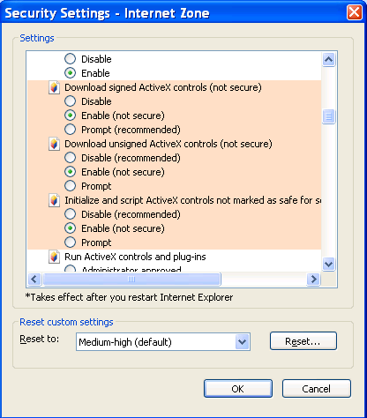
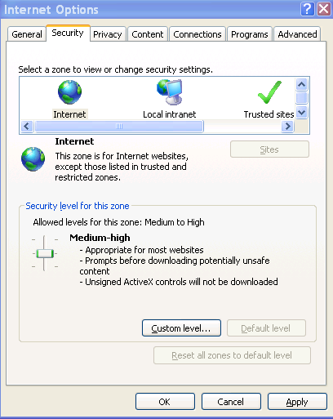
Figure 5- 2
After installation, the interface is shown as below. See Figure 5- 3.
- Please input your user name and password.
Default factory name is admin and password is admin.
- After you have successfully logged in for the first time, you will be asked to change password.
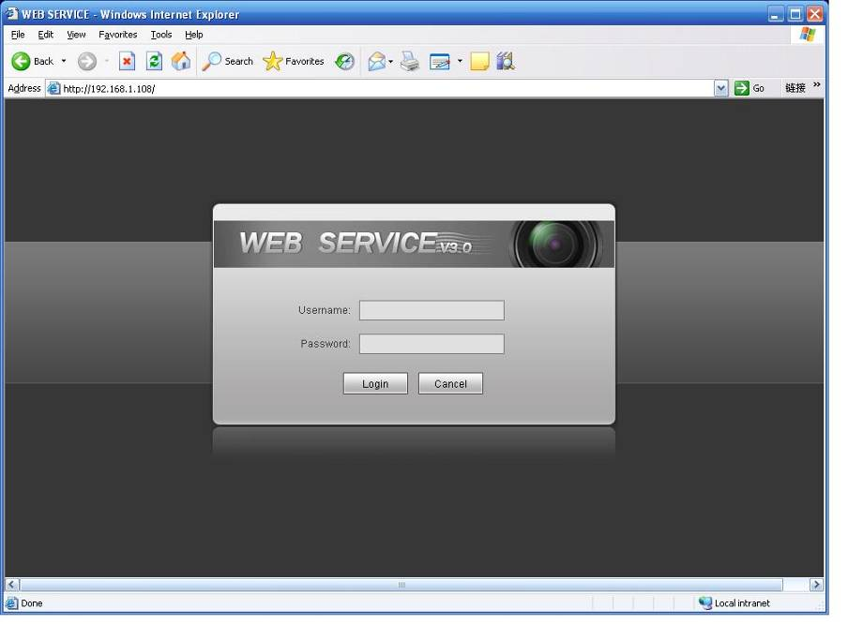
Figure 5- 3
- You can change password according to system prompted password security level. After you have changes password, click OK or you can directly click Cancel, both can enter WEB homepage in Figure 5- 4.
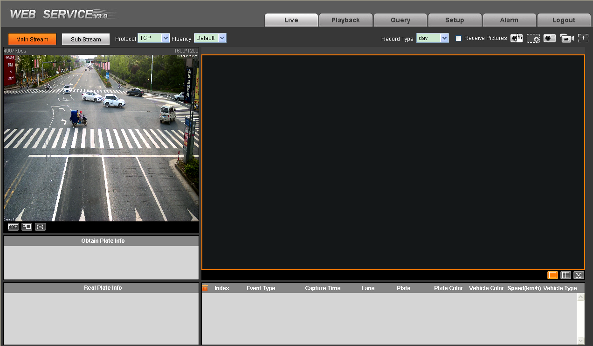
Figure 5- 4
Please refer to the Web Operation Manual included in the resource CD for detailed operation instruction.

Appendix 1 FAQ
Bug | Solution
I cannot boot up the device. | Please click RESET button for at least five seconds to restore factory default setup.
SD card hot swap | Before draw out SD card, please stop record or snapshot first and then wait for at least 15 seconds to remove the SD card.  All the operations before is to maintain data integrity.
SD card write times | Do not set the SD card as the storage media to storage the schedule record file. It may damage the SD card duration.
I cannot use the disk as the storage media. | When disk information is shown as hibernation or capacity is 0, please format it first (Via Web).
I cannot upgrade the device via network. | The status indication light is shown as red when network upgrade operation failed. You can use port 3800 to continue upgrade.
Recommended SD card brand | Kingston 4GB, Kingston 1GB, Kingston 16GB, Transcend 16GB, SanDisk 1G, SanDisk 4G  Usually we recommend the 4GB (or higher) high speed card in case the slow speed results in data loss.
Web control webrec.cab not pop up | Please set IE security level to low and enable ActiveX plug-in.

Appendix 2 Quick Config Tool
Quick configuration tool can search current IP address, modify IP address. At the same time, you can use it to upgrade the device.
Double click the “DH_ConfigTool.exe”icon, you can see an interface is shown as in Figure A2- 1.
In the device list interface, you can view device IP address, port number, subnet mask, default gateway, MAC address and etc.
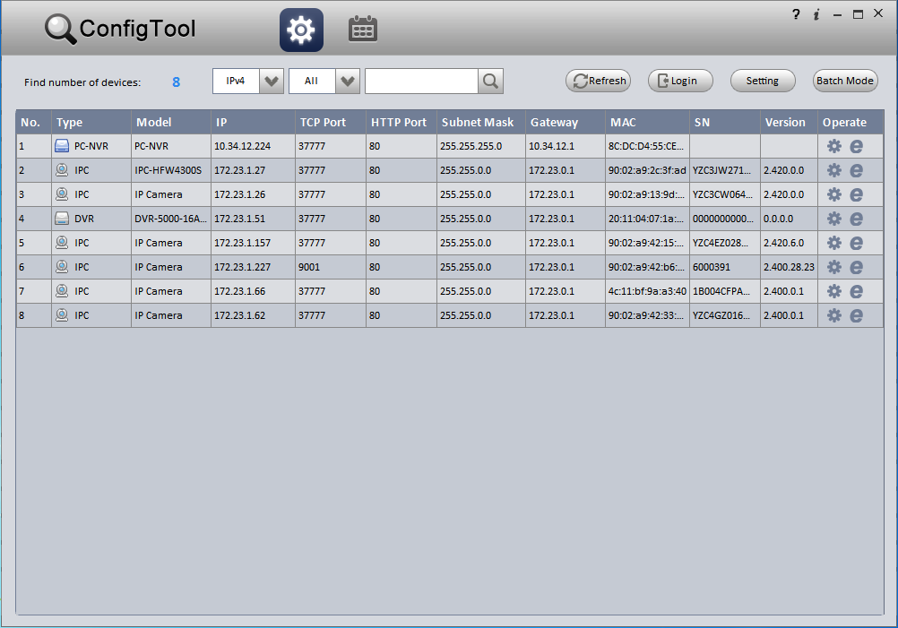
Figure A2- 1
In Quick Config Tool, you can operate:
- Click in device row, to login WEB page. See Figure A2- 2.
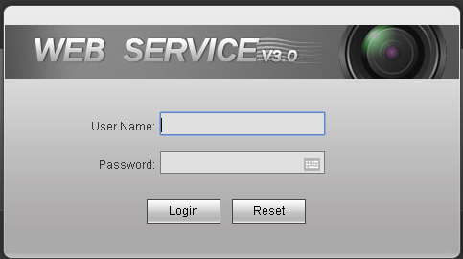
Figure A2- 2
- Double click in a certain row or at the end of row, to login Quick Config Tool page. Here you can set video, net, encode and etc. See Figure A2- 3.
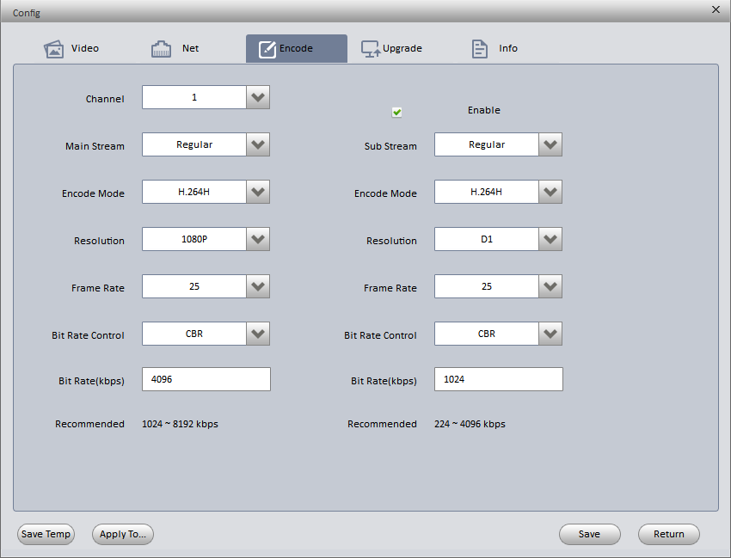
Figure A2- 3
- Click 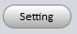, to search device. See Figure A2- 4.
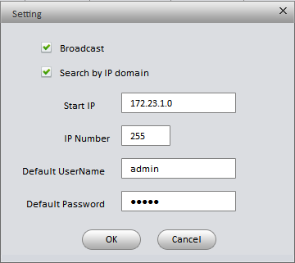
Figure A2- 4
- Broadcast: after you check it, search device in the same segment with current PC.
- Search by IP segment: after you check it, according to start IP and IP quantity search device.
- Click 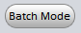 to batch config and upgrade device. See Figure A2- 5.
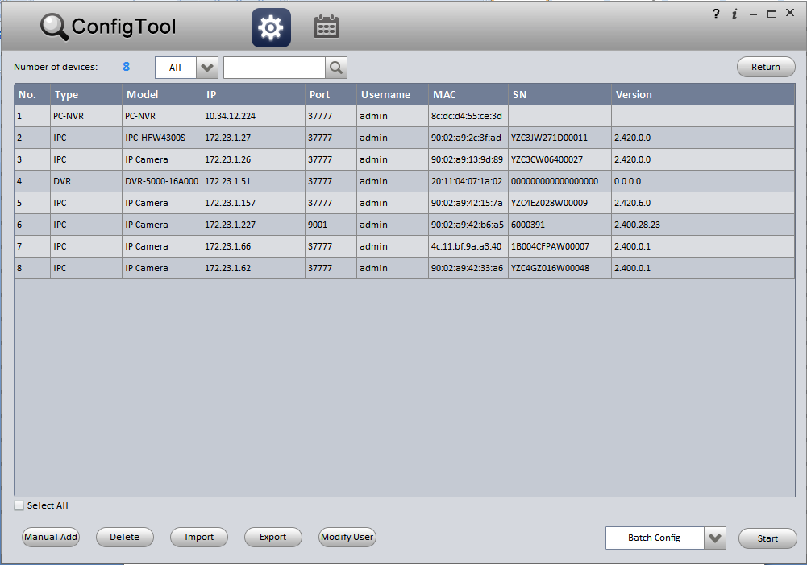
Figure A2- 5

For detailed information and operation instruction of the quick configuration tool, please refer to the Quick Configuration Tool User’s Manual included in the resources CD.

Note:
- This manual is for reference only. Slight difference may be found in the user interface.
- All the designs and software here are subject to change without prior written notice.
- All trademarks and registered trademarks mentioned are the properties of their respective owners.
- If there is any uncertainty or controversy, please refer to the final explanation of us.
- Please visit our website or contact your local retailer for more information.

