Flow Analytics Camera
Web Operation Manual

Version 1.0.1

Important Safeguards and Warnings
1．Electrical safety
All installation and operation here should conform to your local electrical safety codes.
The power shall conform to the requirement in the SELV (Safety Extra Low Voltage) and the Limited power source is rated 90-240V.
We assume no liability or responsibility for all the fires or electrical shock caused by improper handling or installation.

2．Transportation security
Heavy stress, violent vibration or water splash are not allowed during transportation, storage and installation.
Please keep package material well in case you need to send it back to your local retailer or manufacturer for maintenance work.
Non-original package material may result in device damage during the transportation.

3．Installation
Do not apply power to the camera before completing installation.
Please install the proper power cut-off device during the installation connection in case there is any emergency situation.
Always follow the instruction guide the manufacturer recommended.

4．Qualified engineers needed
All the examination and repair work should be done by the qualified service engineers.
We are not liable for any problems caused by unauthorized modifications or attempted repair.

5．Environment
This series camera should be installed in a cool, dry place away from direct sunlight or strong light, inflammable, explosive substances and etc.
The working temperature ranges from -20℃ ~ to +70℃. Please keep it away from the electromagnetic radiation object and environment.
Please keep the sound ventilation.
Do not allow the water and other liquid falling into the camera.
Usually we recommend thunder-proof device to prevent thunder strike.
The GND port of the product shall be grounded to further enhance the reliability of the device.

6. Accessories
Be sure to use all the accessories recommended by manufacturer.
Before installation, please open the package and check all the components are included.
Contact your local retailer ASAP if something is broken in your package.

7. Daily Maintenance
Please shut down the device and then unplug the power cable before you begin daily maintenance work.
Use the dry soft cloth to clean the device.
If there is too much dust, please use the water to dilute the mild detergent first and then use it to clean the device. Finally use the dry cloth to clean the device.

Table of Contents
1 Intro to WEB 1
2 Live 4
2.1 Live 4
2.2 System Menu Bar 4
2.3 Video Bit Stream Bar 5
2.4 Preview Window Switch 5
2.5 Common function bar 7
2.6 Monitor Window Switch 8
3 Playback 9
3.1 Playback 9
3.2 Play 9
3.3 Playback 10
3.4 Progress Bar Mode 13
4 Query 14
4.1 Flow Query 14
4.2 Record Query 14
4.2.1 Record 14
4.2.2 Water Mark 15
5 Setup 17
5.1 ITC 17
5.1.1 Traffic Flow 17
5.1.2 Intelligent 18
5.1.3 Intelligence Default 23
5.1.4 Snap Cutout 24
5.1.5 OSD Config 24
5.2 Camera 27
5.2.1 Attribute 27
5.2.2 Video 33
5.3 Network 35
5.3.1 TCP/IP 35
5.3.2 Connection 37
5.3.3 IP Filter 37
5.4 Event 39
5.4.1 Alarm 39
5.4.2 Abnormity 41
5.5 Storage 42
5.5.1 Destination 43
5.5.2 Record Control 44
5.6 System 44
5.6.1 General 44
5.6.2 Account 47
5.6.3 Default 50
5.6.4 Import/Export 50
5.6.5 Auto Maintain 51
5.6.6 Upgrade 52
5.7 Information 53
5.7.1 Version 53
5.7.2 Log 54
5.7.3 Online User 55
6 Alarm 56
7 Logout 57

Intro to WEB
Default device IP is 192.168.1.108, and to let the device successfully connect to the Internet, you must set PC in the same segment with device.
You can refer to any of the following method to access device and WEB interface, modify device IP and etc.
- Run Quick Config Tool in the accessory disk, search device info, login WEB.
- In the Internet Explorer, input device IP address, press Enter to login WEB.

- In the WEB interface, input username and password (Default username and password are both: admin), click Login. See Figure 1-1.
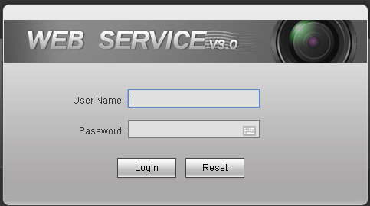
Figure 1-1
- Please change your password after you have successfully login for the first time.
- You can change password according to the password strength level. Click Save when you are done, or click Cancel when you want to exit without modifying current password.
Note:
When you login for the first time, system will prompt you to install or load control unit.
The homepage is shown in Figure 1-2.
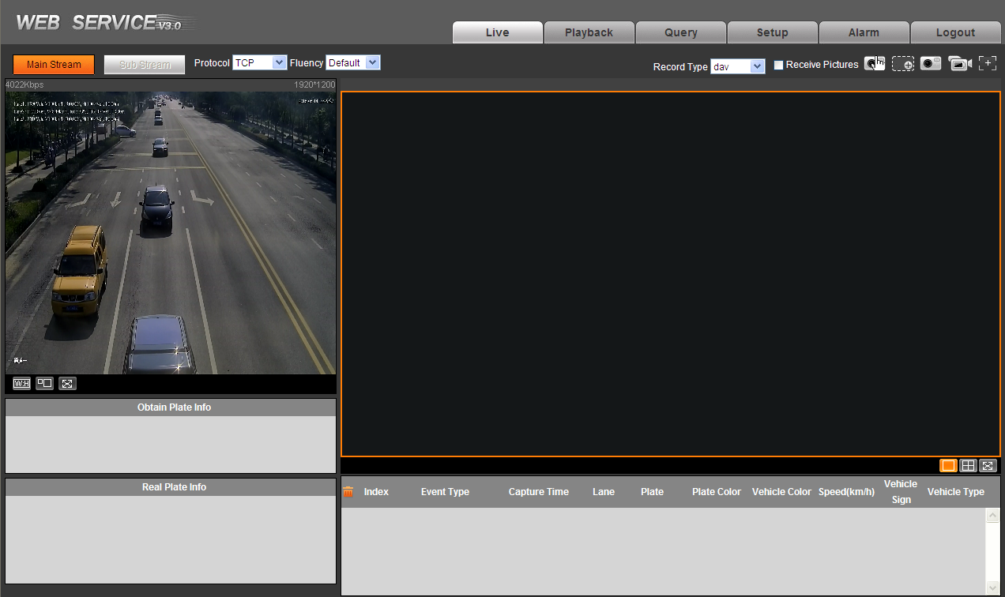
Figure 1-2
Function | Content
Live | Adjust video and image, record video and image and image setup.
Playback | Play record file on hard disk.
Query | Search of picture and video of difference types, watermark and parity.
Setup | Basic camera setup, ITC operation plan, network protocol, alarm time, storage and system management.
Alarm | Alarm prompt.
Logout | Logout the WEB client.
Chart 1-1

In WEB you often the following keys, please refer to Chart 1-2.
Key | Note
 | Click this key, to restore all parameters to default.
 | Click this key, refresh each parameter to the most recent set value.
 | Save current setup.
Chart 1-2
Note:
The interface and setup here are for reference only, please subject to actual product.

Live

Live
After you have successfully login WEB, you can see the live preview page. See Figure 2-1.
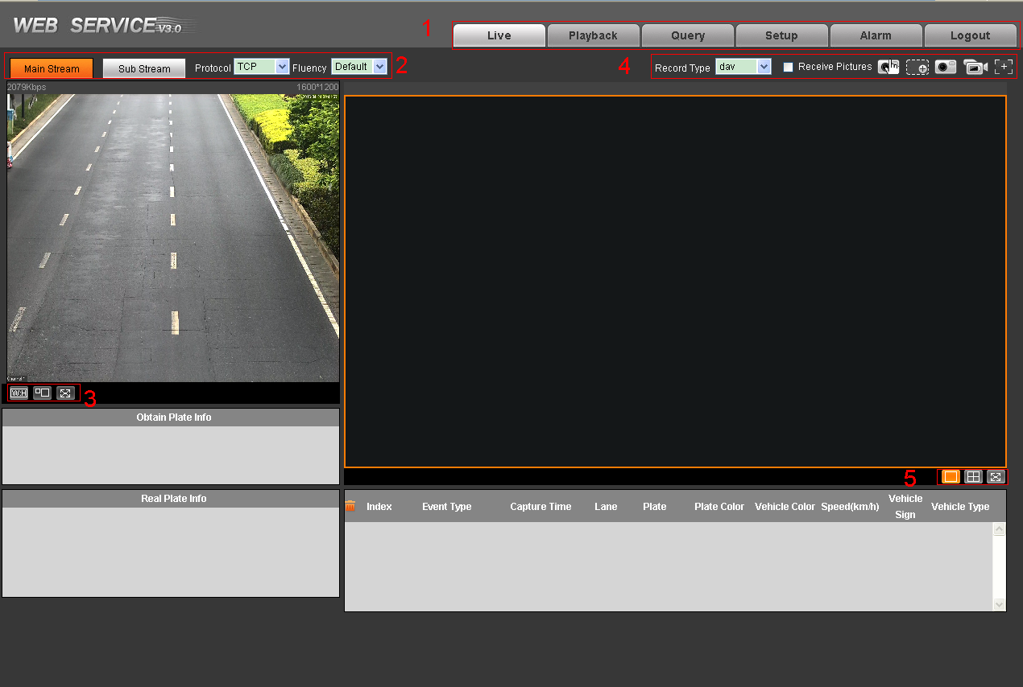
Figure 2-1

No. | Note
1 | System menu
2 | Video bit stream bar
3 | Video window setup bar
4 | Common function bar
5 | Monitor window switch
Chart 2-1

System Menu Bar
System menu bar is described in the following chapters.
See Figure 2-2.
Figure 2-2

Video Bit Stream Bar
Set preview interface bit stream, fluency and etc.
Figure 2-3
Parameter | Function
Main stream | You can use main stream to record video record, network monitor function under normal network environment. You can set resolution within its supported range.
Sub stream | It is a substitute for main stream under insufficient band width.
Protocol | Select video monitoring protocol, currently support TCP only.
Fluency | Select video fluency, from high to default.
Chart 2-2

Preview Window Switch
Figure 2-4
Please refer to the following sheet for detailed information.
Icon | Name | Note
 | Aspect ratio | Adjust image to original size or best fit.
 | Window switch | Window switch to large window and display adjusting window.
 | Full screen | Double click or press Esc.
Click and you can see Figure 2-5.
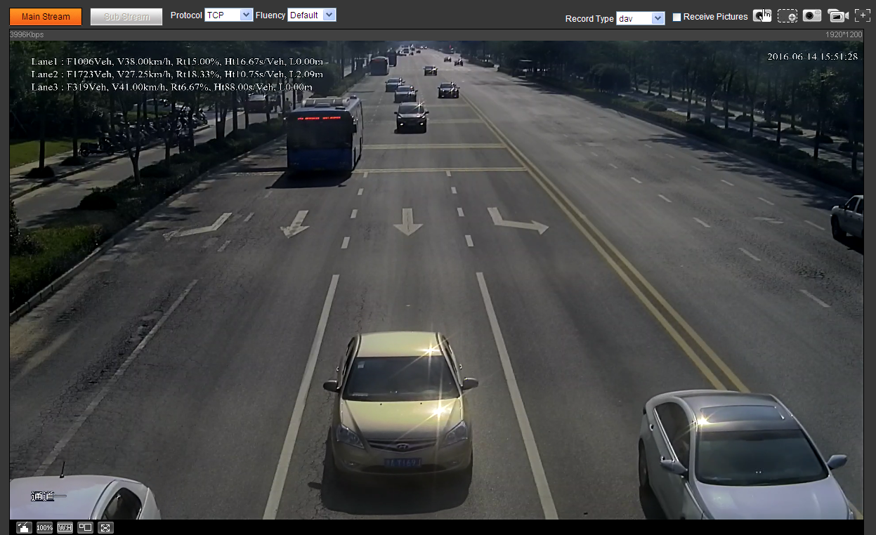
Figure 2-5

Icon | Name | Note
 | Original size | Original size and best-bit size switch. Click to switch to original size.
 | Image adjustment | Display image adjustment window. Click to then off image adjustment.
Click on the right. See Figure 2-6.
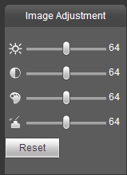
Figure 2-6

Note:
- All the operations here apply to WEB end only.
- Please go to “Setup->Camera->Attributes” to set.

Please refer to the following sheet for detailed information.
Parameter |  | Function
Video setup |  | It is to adjust monitor video brightness. Range 0~128, default is 64.
Video setup |  | It is to adjust monitor video contrast. Range 0~128, default is 64.
Video setup |  | It is to adjust monitor video hue. Range 0~128, default is 64.
Video setup |  | It is to adjust monitor video saturation. Range 0~128, default is 64.
Reset |  | Reset brightness, contrast, hue and saturation to system default values.

Common function bar
Figure 2-7
Please refer to the following sheet for detailed information.
Icon | Name | Note
 | Record Type | Select record file format, default is dav.
 | Receive Pictures | Check this option, system will auto records snapshots. RS485, RS232, video detection and others trigger snapshot, while recording plate, vehicle color, speed and other info will shown below.
 | Manually Snapshot | Click it, to snapshot video.  Snapshots are save to path set in “Setup->Camera->Video>Path”.
 | Partial Zoon In | Click this key, in video window, drag mouse to any area, the area will be zoomed in. Right click select exit or left click to exit.
 | Snapshot | Click it, snapshot picture from video stream, and save to set path.
 | Record | Click it, to start recording.  Click to stop recording.
 | Easy Focus | N/A

Monitor Window Switch
Figure 2-8
Please refer to the following sheet for detailed information.
Icon | Name | Note
 | Single window | Single window display.
 | Four window | Four window display.
 | Full screen | Full screen display.

Playback

Playback
Open Playback menu on System Menu bar, and you can playback video on SD card.
WEB client playback interface is shown in Figure 3-1.
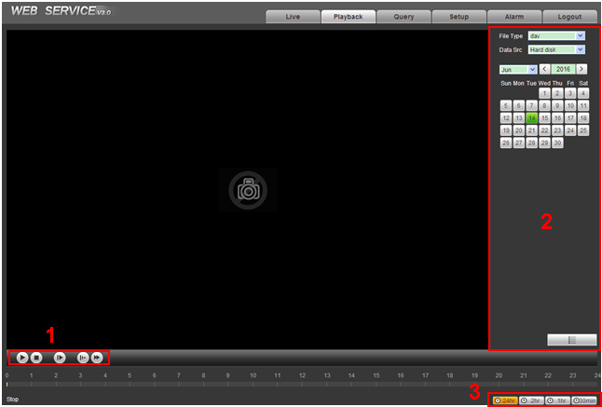
Figure 3-1
No. | Bar Name
1 | Play fucntion bar.
2 | Playback file bar.
3 | Time progress standard bar.
Chart 3-1

Play
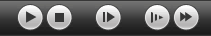
Figure 3-2
Icon | Parameter | Note
 | Play | When you can view this key, the video is paused or not player yet, click this key to play.
 | Stop | Stop video.
 | Next frame | Go to next frame.
 | Slow | Slow down play speed.
 | Fast | Speed up play speed.

Playback
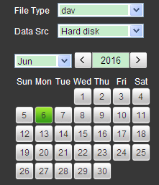
Figure 3-3
Date shown in orange background, means the date has record file.
- Select “dav” file type and data source. Select record data. Default data source is SD card by default. If there is no SD card, then it cannot play.
- Click date in orange background, the time bar will show record file in color.
Orange means the date has record, and when you select it, it turns blue. Green means there is no record on this date.
- Click a certain time point in record file progress bar, the playback interface will play record from this time point.
Figure 3-4
- Click , select record file of the seleted date in list.
- Double click list, system will play the file and you can see file size, start time and end time. See Figure 3-5.
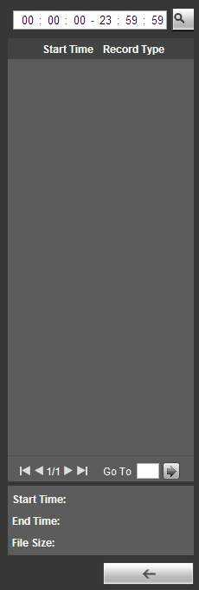
Figure 3-5
Parameter | Note
Search | Search all records between selected date’s input start time and end time.
Download | Click download key to download file to local.
Return | Click return key, return to calendar page. You can select time again.

Progress Bar Mode
Figure 3- 1
Parameter | Note
24 hours | Progress bar display in 24-hour mode.
2 hours | Progress bar display in 2-hour mode.
1 hour | Progress bar display in 1-hour mode.
30 min | Progress bar display in 30-min mode.

Query
Open Query function on WEB, here you can search for flow and record.

Flow Query
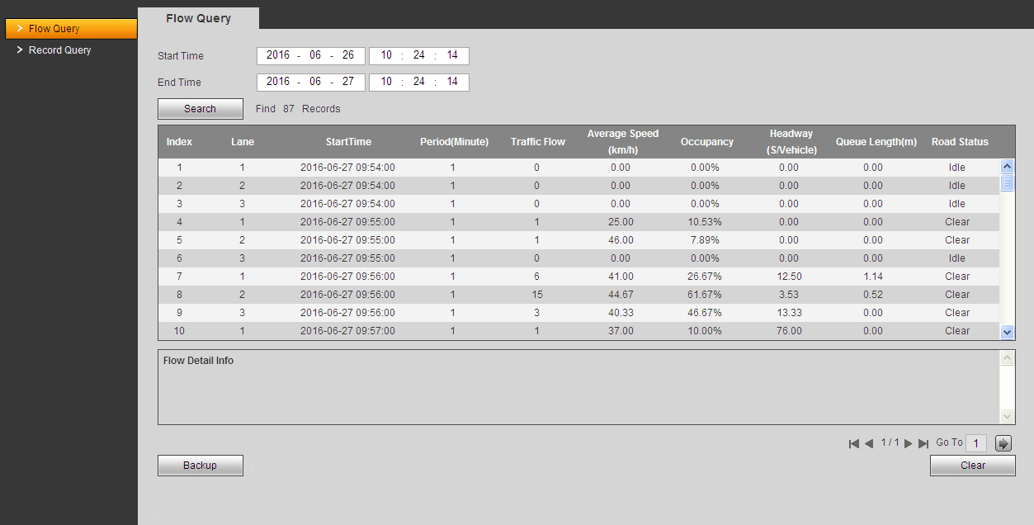
Figure 4-1
- Set range of query time, click Search.
In list it shows current period, flow in each channel every minute. It includes traffic flow, average speed, occupancy, headway, queue length and road status of the lane at current time.
Note:
Click Stop to end current search.
- Select a row in list, to view flow details in current index.
In flow list, it includes details flow statistics of each type of vehicle in current lane during selected period.
- Click Backup to save current query result to specific path, you can click Clear to delete all results.

Record Query

Record
Click Record Query, you can see an interface is shown as in Figure 4-2. Open local record, select record on PC to play.
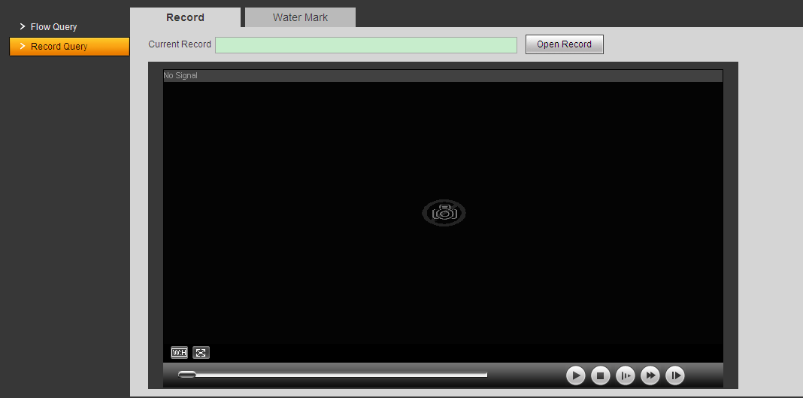
Figure 4-2
Note:
Please refer to Ch 3.2 for play function.

Water Mark
Note:
Before user uses this function, please enable watermark function in “Setup>Camera>Video”. Set corresponding watermark characters, and default is DigitalCCTV.
Select record file, click Water Mark, system display verification progress and normal watermark. See Figure 4-3.

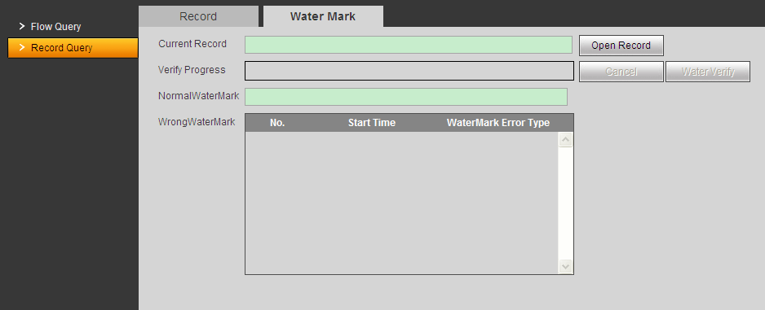
Figure 4-3
After you are done, the page will display watermark is finished.

Setup

ITC
Here set ITC operation rule.

Traffic Flow

Traffic Flow
After camera and signal switching device are matched, you can view traffic flow result on signal device.
- Select Setup>ITC>Traffic Flow.
- Set statistical period.
- Select lane for statistics.
- Check Enable.
- Click Save. See Figure 5-1.
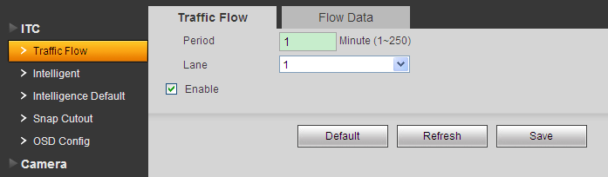
Figure 5-1

Flow Data
In Setup>ITC>Flow Statistics>Flow Data, view flow data of each period and each channel.
When statistical period ends, flow data will update.
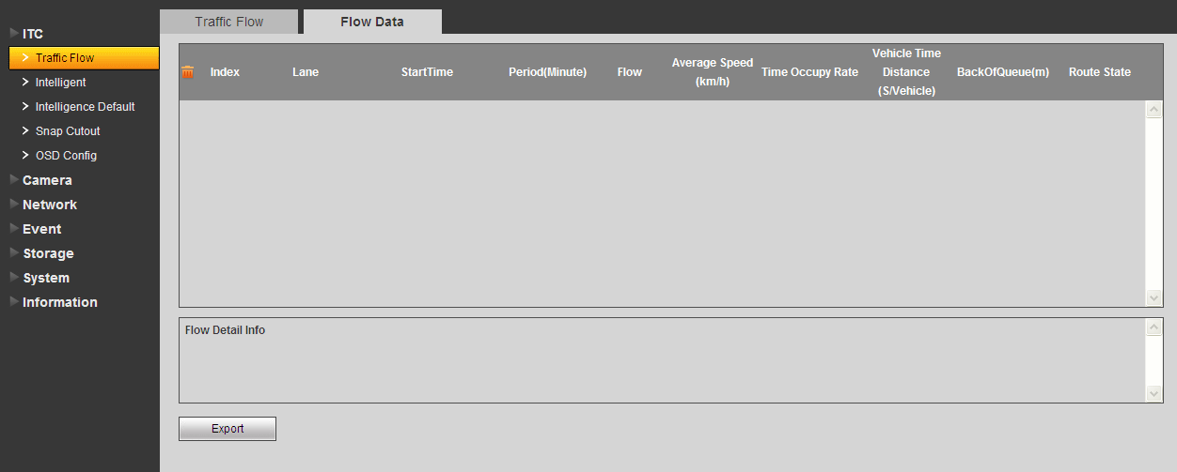
Figure 5-2
- Click a single row, you can view detailed flow info of corresponding period and lane.
- Click to clear flow data.
- Click Export to export flow data of the zone to local.

Intelligent

Scene Setup
Here draw scene config line.
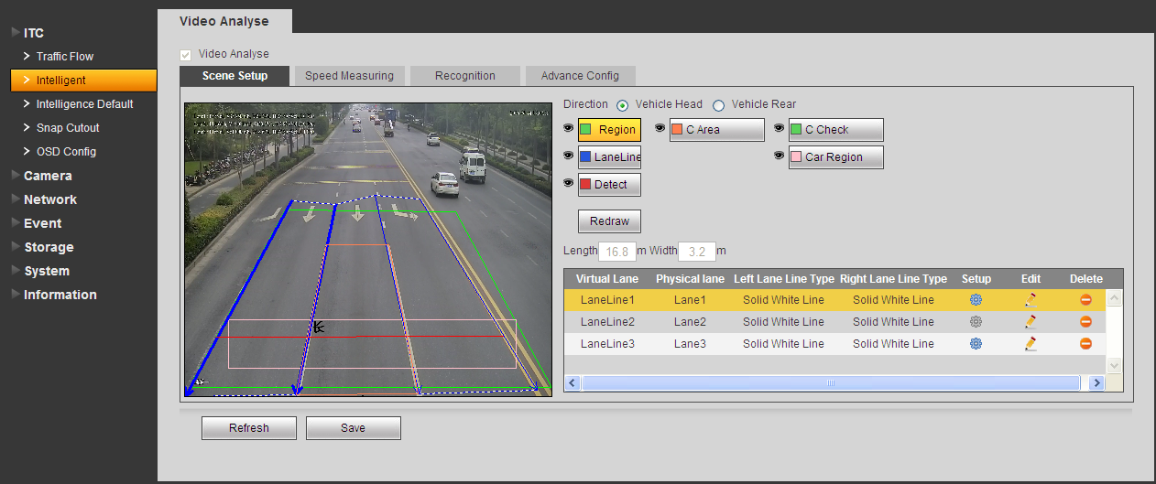
Figure 5-3
- Select Setup>ITC>Intelligent>Video Analysis.
- Select config line type you want to draw.
- Draw lines in the scene.
Note:
Click Redraw to delete current drawn line.

Parameter | Note
Region | Drawn virtual lane.
Lane Line | Drawn according to the actual need to detect lane of traffic.  Need two lanes each lane lines.  Lane line arrow indicates the direction the vehicle is traveling.  Select it and click "redraw" to display the field of vision in the left side of the interface drawing, as the figure above the blue line.  Only under the direction of the angle at the interface of the above rendering, the angle can not be drawn about.
Detect | Draw trigger capture intelligent boundary line with the actual traffic in the role of a coil, when the vehicle to the test line to trigger snap pictures.  Test line has been drawn only in the lane to achieve beyond the area will not be displayed.  Select it and click "redraw" to display the field of vision in the left drawing interface, as shown by the red lines.
C Area | Both configurations used to calculate and verify the actual line from the road surface, in order to achieve speed function.  Draw specific steps are as follows:  1. Select the "calibration regions", drawn quadrilateral area.  2. Enter the pavement in the calibration region "long", "W" in the actual length and width.  3. Select the "Calibration Verification" to draw a line to be verified.  4. The system displays the dialog box to verify the length of the line, testing whether the value of the actual match:  - If the value is correct, complete the configuration.  - If the value is not correct, again select "calibration area", each vertex of the quadrilateral move or re-enter the length and width values; draw "Calibration Verification" lines again after the setup is complete, verify that the line length and the actual match. Repeat this step until you verify correct.  Note:  For the exact value in the calibration verification, draw lines on the screen in different directions, and multiple verification; repeatedly verified the results were consistent with the actual case, to complete the configuration.
Check
Car Region | Draw range to detect traffic flow.
Chart 5-1
- When you complete drawing, it auto shows lane info, click or to set corresponding lane. Or you can click to delete current lane line. After setup, in pop-up interface click Save.

Figure 5-4
Parameter | Note
Virtual Lane | Set drawn lane name.
Physical Lane | According to actual road condition set lane no.
Left Lane Line  Right Lane Line | Set lane type, you can select while line, dotted line and yellow line.
Left Border  Right Birder | After check, image beyond left/right lane lines will not be analyzed.
Chart 5-2
- Click Save below to make current setup effective.

Speed Measuring
By configuring camera installation info, it measures speed of vehicle.
Select Setup>ITC>Intelligent>Video Analysis>Speed Measuring. Set parameters as follows. Click Save.
See Figure 5-5.

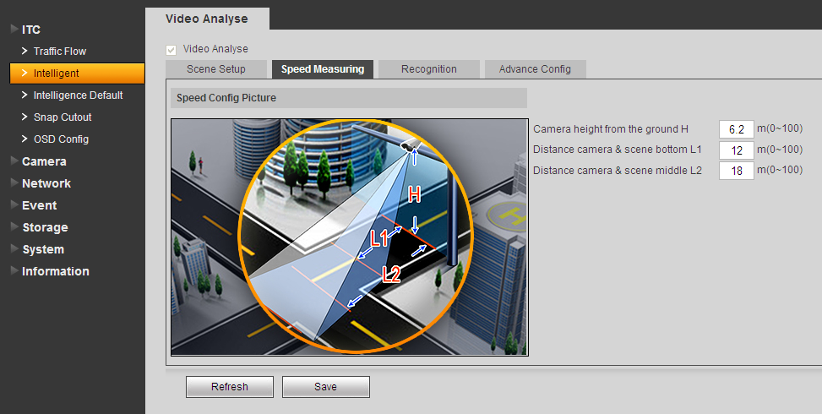
Figure 5-5

Parameter | Note
Camera height from the ground H | This is the actual height of the camera from the ground.  Note:  This value must be the same as the value of the actual laying, otherwise the video speed will be inaccurate.
L1 | L rod distance of lower image border.  Note:  This value must be the same as the value of the actual laying, otherwise the video speed will be inaccurate.
L2 | This is the middle line in image (ie the yellow line, the middle line, ranging fellow-field image of yellow lines on the road) distance to L rod.  Note:  This value must be the same as the value of the actual laying, otherwise the video speed will be inaccurate.
Chart 5-3

Recognition
Via recognition, snapshot vehicle without a plate and it can recognize location of vehicle plate.
Select Setup>ITC>Intelligent>Video Analysis>Recognition. Set parameters as follows. Click Save. See Figure 5-6.
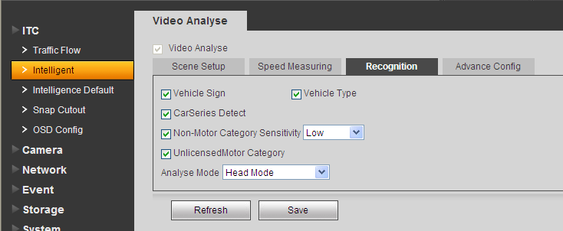
Figure 5-6

Parameter | Note
Vehicle Sign | Vehicle brand sign.
Vehicle Type | Vehicle type.
Car Series Detect | Detect vehicle series.
Non-Motor Category | Select this argument, capture non-motorized vehicles and pedestrians. When enabled, select the "sensitivity."
Unlicensed Motor Category | Select this argument, capture unlicensed vehicles.
Analysis Mode | Selectable modes include license plate recognition: Only the front license plate recognition, recognizes only the rear license plate, front license priority, rear license preferred.
Chart 5-4

Advance Config
Select Setup>ITC>Intelligent>Video Analysis>Advance Config. Set parameters as follows. Click Save.
See Figure 5-7.
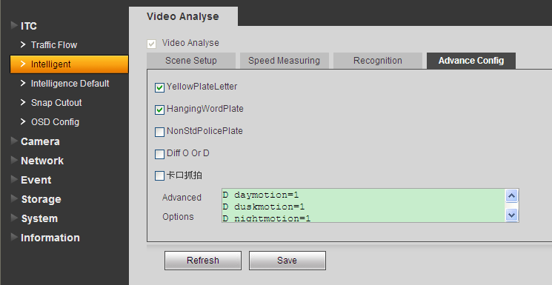
Figure 5-7

Parameter | Note
Yellow Plate Letter | These needed to enable the corresponding type identifies the license plate.
Hanging Word Plate
Non Std Police Plate
Diff O or D
ANPR Snapshot
Advanced Options | You can enter a custom algorithm expression, to achieve special features custom.
Chart 5-5

Intelligence Default
Select Setup>ITC>Intelligence Default. Click on default to restore default settings.
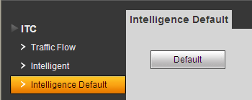
Figure 5-8

Snap Cutout
Select Setup>ITC>Snapshot Cutout. Check Snapshot Cutout Enable, click Save. The system will identify the license plate, the main driver of the face, the co-pilot who plucked out a picture of the face images stored in the storage path. See Figure 5-9.
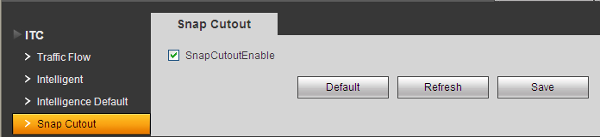
Figure 5-9

OSD Config

Video OSD
Set video channel OSD. See Figure 5-10.
- Select Setup>ITC>OSD Config>Video OSD.
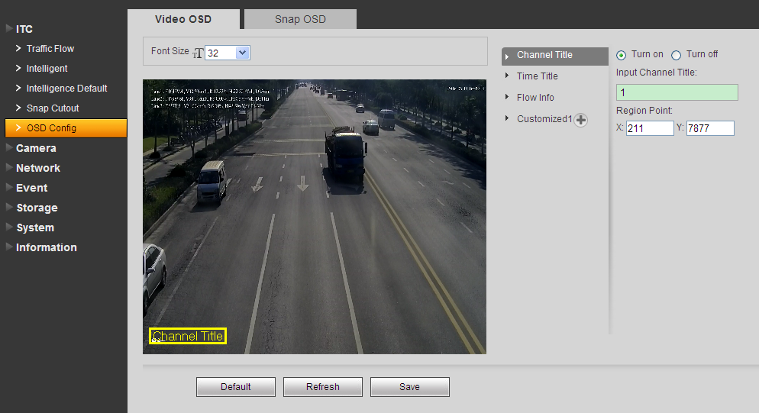
Figure 5-10
- Select font size and solution. Set OSD font.
- Set channel title and location.
  - Select channel title.
  - Check Turn on.
  - Input channel name.
  - Use the mouse to drag the yellow box or change the regional point coordinates, select the channel position title.
  - Click Save.
- Set time title and position.
  - Select time title.
  - Check Turn on.
  - Check week.
  - Use the mouse to drag the yellow box or change the regional point coordinates, select the time the title of the position.
  - Click Save.
- Set flow info and position.
  - Select Flow Info.
  - Check Turn on.
  - Use mouse to drag box or change region coordinate, select time title position.
  - Click Save.
- You can click to add customized region, define OSD info.
The system supports up to 6 customized regions.
- Click Save.

Snap OSD
Set snap OSD information and location, OSD options include time, driveways name, week, location, speed, license plate, illegal code and other information.
- Select Setup>ITC>OST Config>Snap PSD. See Figure 5-11.
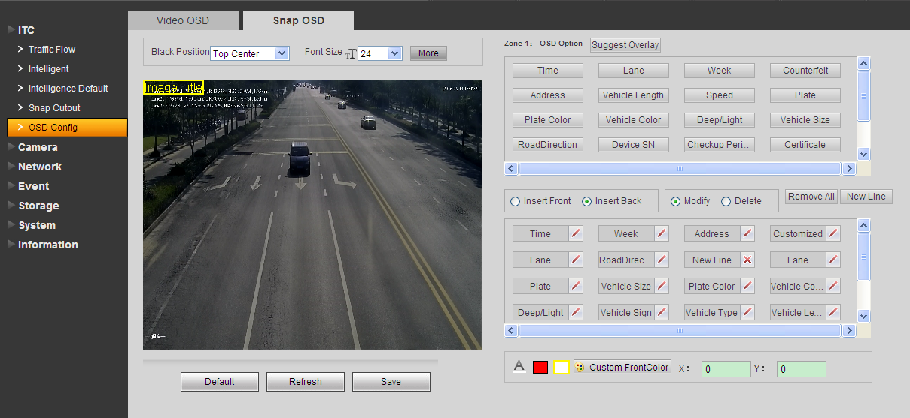
Figure 5-11
- Select any region in video, and drag mouse to add snapshot title. Move box to place you want to display it, or enter coordinate value in X/Y field on the right.
The system supports up to 8 snapshot titles, and each snapshot can customize OSD.
Note:
Select a snapshot, right click to delete current snapshot title.
- Select OSD black border position, including top, bottom or none.
- Set OSD info font size and font plan. At the lower right corner, you can set snapshot OSD info font color.
- Click More, to pop up new line and OSD separator. According to actual need, check new line, and set OSD info separator.
Select custom, to manually enter other separator.
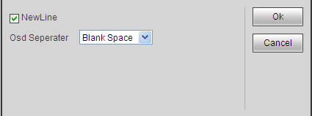
Figure 5-12
- Set OSD option.
Tips:
Click Suggest Overlay to quickly set common overlay mode.
Parameter | Note
Insert Front/Back | OSD option to adjust the order selected between.
Modify | All selected OSD information state by turns, you can modify any OSD options prefix, suffix, and other content, and the number of separators.
Delete | All selected OSD information state by turns, you can delete any OSD options.
Remove All | Clear all selected OSD information.
New Line | OSD information will be displayed on the picture branches.
Chart 5-6
- Click Save.

Camera
Here set camera attributes, light, storage path and etc.

Attribute

General
Here set image brightness, contrast, mode and etc.
Select Setup>Camera>Attributes>General, set parameters as follows, then click Save.

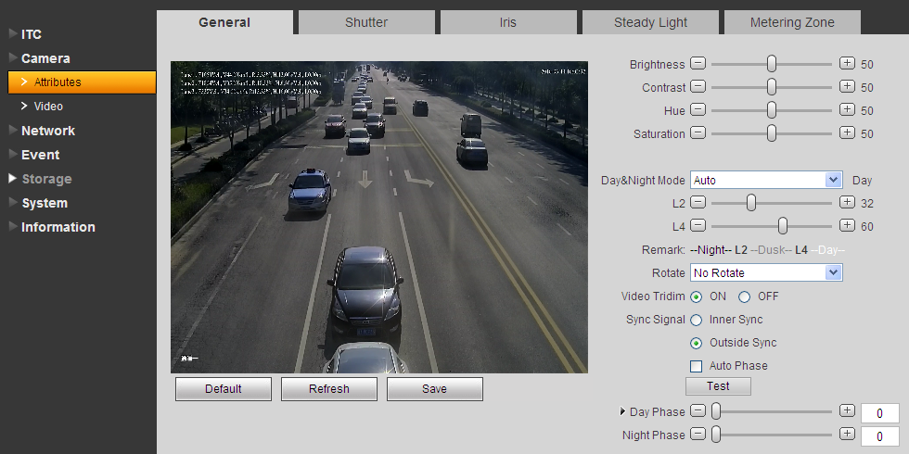
Figure 5-13

Please refer to the following sheet for log parameter information.
Parameter | Function
Brightness | The value adjusts brightness of full image. Default value is 50. The higher the value, the brighter the image. When image is too bright or too dark, you may adjust this value. Recommended value is 40~60 within 0~100 range.
Contrast | The value adjusts contrast of full image. Default value is 50. The higher the value, the higher the contrast of image. When contrast is insufficient, you may adjust this value. Recommended value is 40~60 within 0~100 range.
Hue | The value adjusts hue of image. Default value is 50. It will not affect image brightness. It has a relatively fixed value according to the sensor. Recommended value is 40~60 within 0~100 range.
Saturation | The value adjusts saturation of image. Default value is 50. The higher the value, the deeper the color. It will not affect image brightness. When WDB is inaccurate, this value may cause color difference in grey area. Recommended value is 40~60 within 0~100 range.
Day/Night mode | Switch of color and black&white. It includes color, by brightness and black&white.
L2 | Set switch threshold of night and evening. When environmental brightness is below this value, camera will auto switch to night snapshot mode.  Note:  This value only can be set to value equal to or below L4 value.
L4 | Set switch threshold of day and evening. When environmental brightness is below this value, camera will auto switch to day snapshot mode.  Note:  This value only can be set to value equal to or above L2 value.
Rotate | N/A
Video 3D NR | Check Enable to enable 3D NR.
Picture 3D NR | Check Enable to enable 3D NR.
Sync signal | Divided into inner sync and outside sync.  Outside sync can be set by dragging the slider to the day and night were a fixed synchronous phase value, adjust the red light or dark under different scenarios.  1, check the "automatic phase."  2. Select the signal area, the system displays the green box and enlarge the area.  3. Select the need to adjust the lights, the system displays a yellow box.  4. Click "Test", the system default given day and night phase synchronization interval.  5. You can also click the "Settings" to adjust the appropriate phase value.  6. Right click to cancel zoom in, and click again to exit the selected area.  7. Click Save.
Day Phase | Manually adjust day sync signal phase value.
Night Phase | Manually adjust night sync signal phase value.
Chart 5-7

Shutter
Here set shutter, exposure, gain and scene mode.
Select Setup>Camera>Attribute>Shutter, set parameters as follows. Click Save. See Figure 5-14.

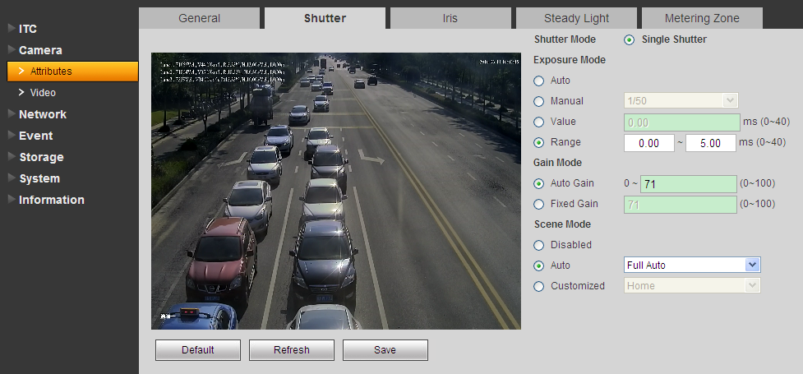
Figure 5-14

Please refer to the following sheet for log parameter information.
Parameter | Function
Shutter mode | Single shutter only.
Exposure mode | Select exposure mode: auto and manual. You can set manual exposure mode as 1/50～1/10000. You may also customize.
Scene mode | - Select device scene mode to adjust video to best effect.  - May set auto, sunny, cloudy and etc.
Gain mode | - Auto gain: set camera auto max gain according to external brightness.  - Fixed gain: set camera fixed gain.
Chart 5-8

Iris
Here set iris mode.
Select Setup>Camera>Attributes>Iris, set parameters as follows, and click Save. See Figure 5-15.
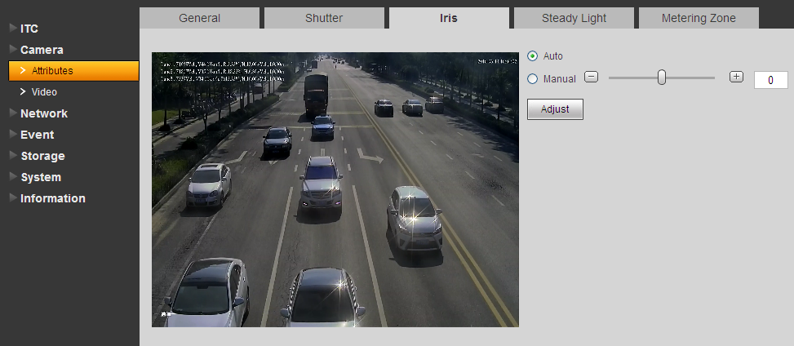
Figure 5-15
Parameter | Note
Auto | Adjust iris size accordingly.
Manual | Drag bar or input value to adjust iris size.
Chart 5-9

Steady Light
Select Setup>Camera>Attributes>Steady Light, set parameters as follows, and click Save. See Figure 5-16.
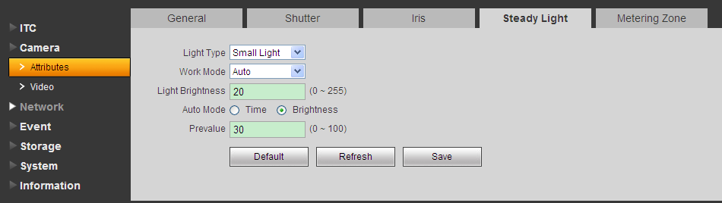
Figure 5-16
Please refer to the following sheet for log parameter information.
Parameter | Note
Serial | Select 1 or 2 according to NO/NC read panel port
Light Type | Select steady light type.
Work Mode | Select work mode：  - off：steady light always off.  - on：steady light always on.  - auto：according to environmental light or time enable light automatically.
Light Brightness | Set light normal brightness.
Auto Mode | Select auto on standard of light.
Prevalue | Set light auto on environmental prevalue.  When environment brightness is below this value, light auto turns on.
Time | Click Time option.  Check week you want to turn on light and set corresponding period.
Chart 5-10

Metering Zone
Here you can select spot measure and backlight modes.
Select Setup>Camera> Attribute>Metering Zone. See Figure 5-17.
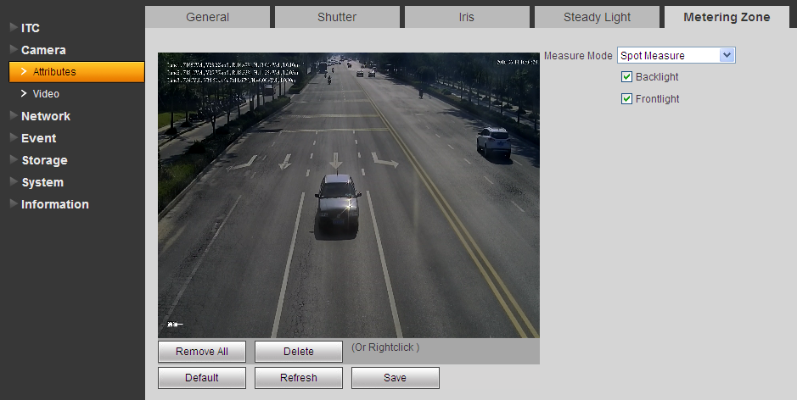
Figure 5-17

Please refer to the following sheet for log parameter information.
Parameter | Function
Metering zone | - Spot measure: For moving vehicle.  - Full measure: For entire zone.  - Partial measure: For sensitive zone. If the zone is bright, entire zone will be dark and vice versa.
Backlight | According to the actual needs of the scene, select the backlight brightness compensation rolls supplement and enhance the brightness of the screen backlight.
Chart 5-11

Video

Video
Select Setup>Camera>Video>Video. See Figure 5-18.
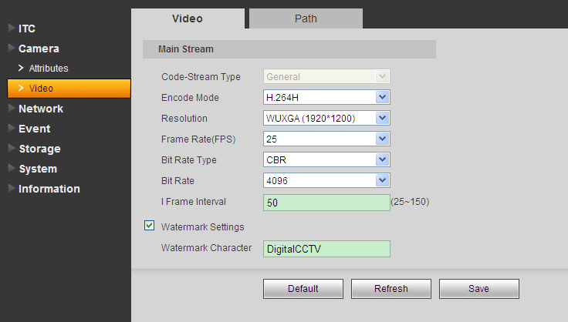
Figure 5-18
Please refer to the following sheet for log parameter information.
Parameter | Function
Code-stream type | Now support only general steam.
Encode mode | Support H.264B, H.264 M, H.264H and MJPEG encoding.
Resolution | Now support WUXGA, 1080P, 720P.
Frame rate (FPS) | Set frame rate, max support 25.
Bit rate type | It includes: CBR and VBR. Under VBR, you can set image quality.
Bit rate | - Under VBR, this value serves as upper limit. Under CBR, this value is fixed.  - It is the best range of bit rate.
I frame interval | It is the P frame between two I frame, with range 25～150. Default is two times frame rate.
Watermark settings | By verifying watermark character, you may check if record is edited. Check front box to enable function. Default watermark character is: DigitalCCTV. Only number, letter, and underline are supported, max 85 characters.
Chart 5-12

Path
Here set snapshot and record naming rule, storage path. Click Help to view the naming rule.
Select Setup>Camera>Video>Path. See Figure 5-19.
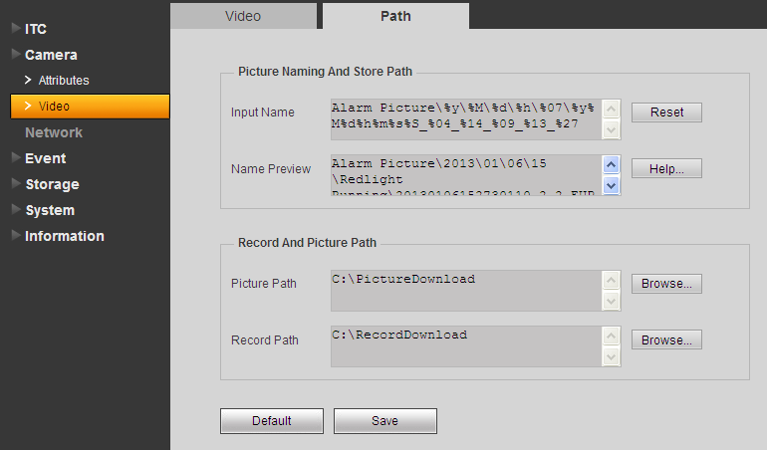
Figure 5-19

Network
Here set IP address, right and etc.

TCP/IP
Here set host name, IP address and etc.
Select Setup>Network>TCP/IP. See Figure 5-20.
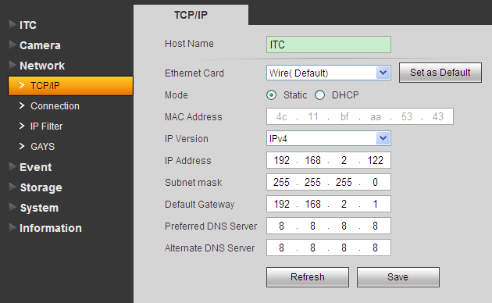
Figure 5-20

Please refer to the following sheet for log parameter information.
Parameter | Function
Host name | Set current host name. Max supports 32 characters.
Ethernet card | Set Ethernet card to config. Default is wired.
Mode | You can select from static and DHCP mode. In DHCP mode, it automatically search IP while you cannot set IP/subnet mask/gateway. Plus IP/subnet mask/gateway display values from DHCP. In static mode, you shall manually set IP/subnet mask/gateway. To switch from DHCP to static, you must set IP parameters again.
MAC address | Display host MAC address.
IP version | Select IP version IPV4 or IPV6. These two IP addresses both can be accessed.
IP address | Input new IP address to edit, and set subnet mask and default gateway.
Preferred DNS | DNS server IP address.
Alternate DNS | DNS server alternate IP address.
Chart 5-13

Connection

ONVIF
ONVIF is Open Network Video Interface Forum, an online video to achieve a framework agreement, which are produced by different vendors of network video products (such as front-end cameras, video equipment, etc.) is fully interoperable.
Select Setup>Network>Connection>ONVIF.
Check the open ONVIF login, login ONVIF need a username and password verification; turn off the feature you do not need validation. See Figure 5-21.
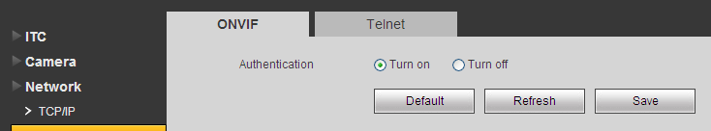
Figure 5-21

Telnet
Telnet service is turned on, you can use Telnet service, turn off the feature can not be used. See Figure 5-22.
Select Setup>Network>Connection>Telnet.
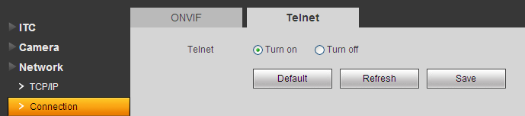
Figure 5-22

IP Filter
By setting the trusted and banned lists, you can enable or disable some users log in to the device. Devices allow trusted list the IP address of the user to log in, and ban the IP address blacklist users log device. Supports adding IP or IP range. See Figure 5-23.
For example to add IP into trusted list.
- Select Setup>Network Setup>IP Filter>Trusted List.
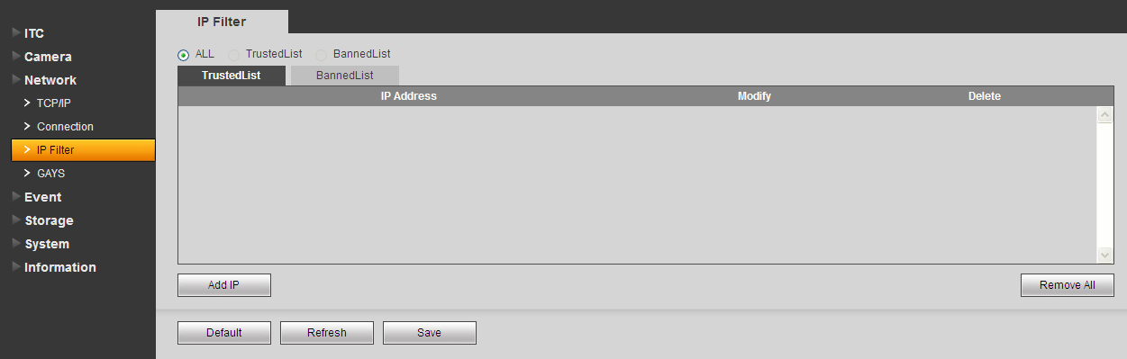
Figure 5-23
- Click . See Figure 5-24.
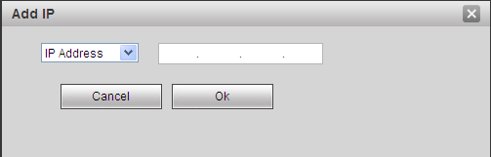
Figure 5-24
- Select IP or IP segment, click Save. See Figure 5-25.
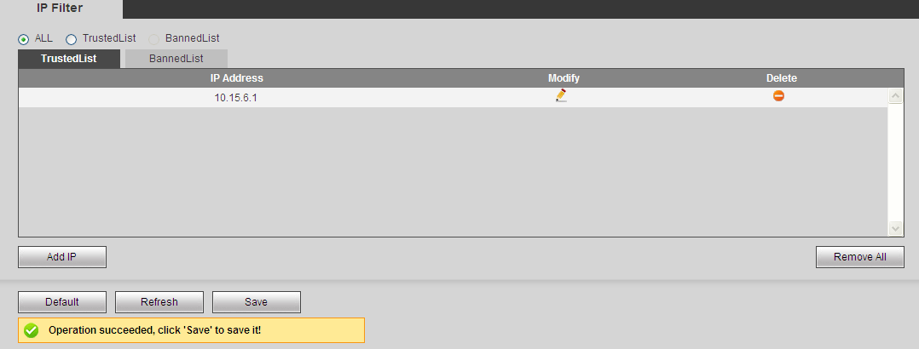
Figure 5-25
- Click Save in Trusted List tab.
- System informs you it has been successfully saved.
In Trusted list tab, you can:
- Click to modify existing IP address or IP segment.
- Click to delete existing IP address or IP segment.
- Click to clear all IP address in list.
Note:
Banned list can be set in similar way as trusted list.

Event
Here set alarm and process abnormality.

Alarm

Relay Activation
Connect alarm output device to corresponding port of I.O port cable.
Note:
The device supports 1-ch alarm input and 1-ch alarm output.
- Select Setup>Event>Alarm>Relay Activation. See Figure 5-26.
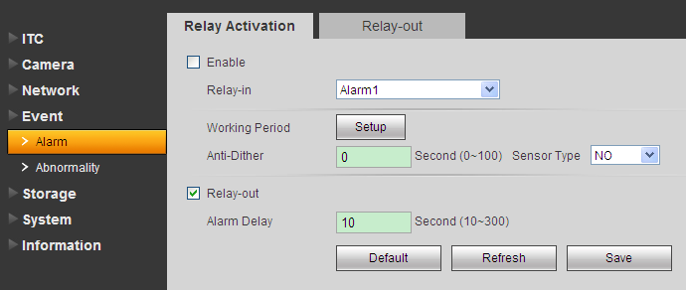
Figure 5-26
- Check Enable.
Please refer to the following sheet for log parameter information.

Parameter | Function
Relay-in | Only support one relay in for now.
Working period | Set alarm arm and disarm period. Click on setup key to open period menu.
Anti-dither | During anti-dither period, only one alarm will be recorded. Unit is second with range 0s～100 s.
Sensor type | May set NO or NC.
Chart 5-14
- Check relay out, and set delay time.
- Click Save.

Relay-out
The relay-out interface is shown as in Figure 5-27.
- Select Setup>Event>Alarm>Relay-out.

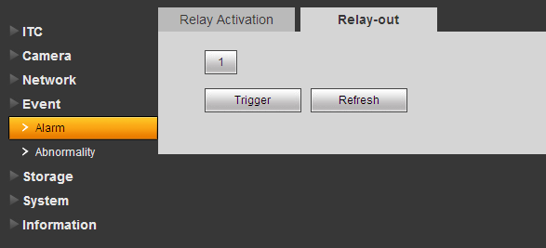
Figure 5-27
- Click 1, set 1-ch relay-out.
- Click Trigger to output alarm output signal.
- Click Refresh, to search alarm output status.

Abnormity
The abnormity interface is shown as in Figure 5-28.
Select Setup>Event>Abnormal, according to your need, check Enable, relay-out and etc.
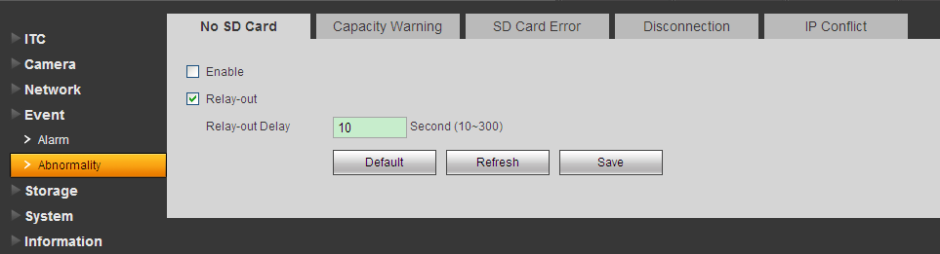
Figure 5-28

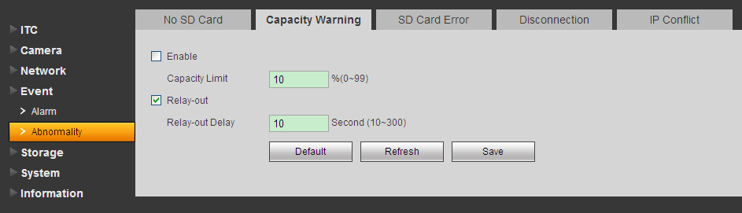Figure 5-29

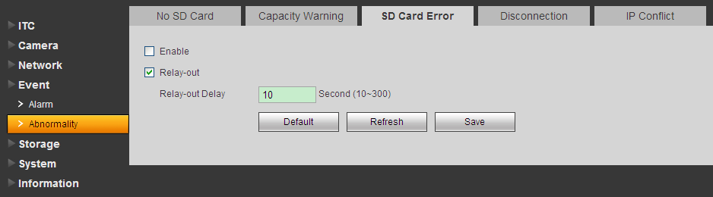
Figure 5-30

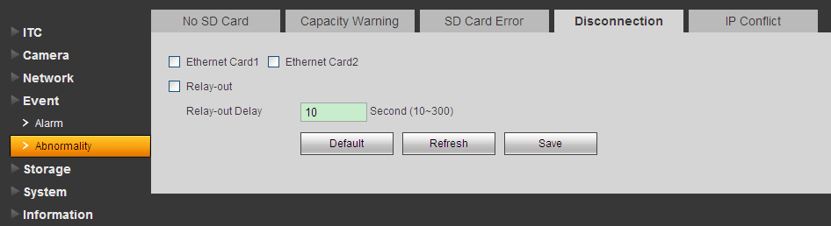
Figure 5-31
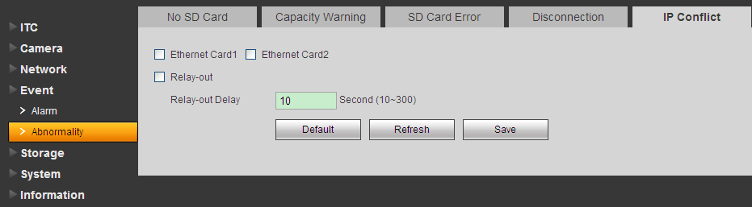
Figure 5-32

Please refer to the following sheet for log parameter information.
Parameter | Function
Enable | Check, to enable corresponding processing of abnormality.
Relay-out | Check to enable corresponding relay-out.
Relay-out Delay | Set alarm delay time.
Capacity Limit | Set triggered SD card capacity max.
Ethernet card 1, Ethernet card 2 | Check Ethernet card to enable alarm.
Chart 5-15

Storage
Here set storage and record control.

Destination

Path
Config record and snapshot, includes: local SD card storage and FTP storage. You cannot select local and local emergency at the same time.
Select Setup>Storage>Destination>Path.
The path interface is shown as in Figure 5-33.

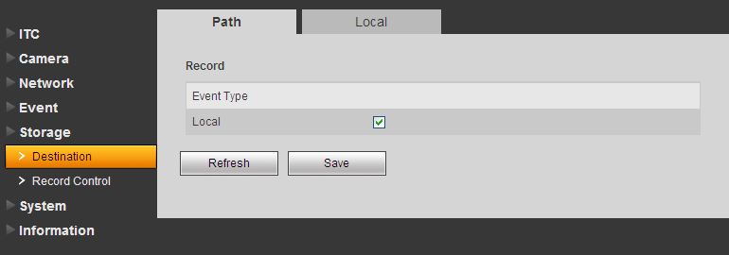
Figure 5-33

Local
The list displays local SD card or HDD info; you may perform read-only, write-only, hot swap and formatting. See Figure 5-34.
Select Setup>Storage>Destination>Local.

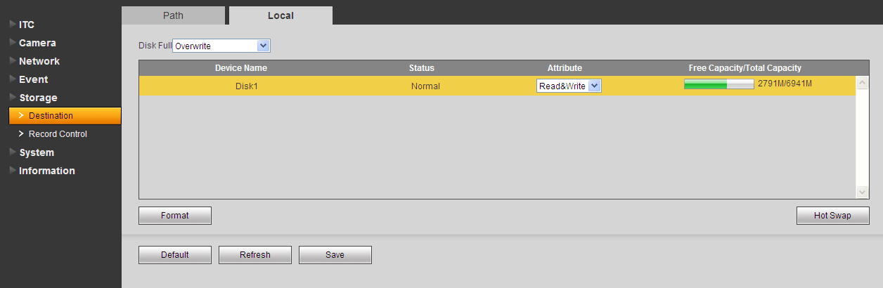
Figure 5-34

Record Control
Select Setup>Storage>Record Control.
Select record mode and record stream. If you select Off for record mode, then you cannot link record.
See Figure 5-35.

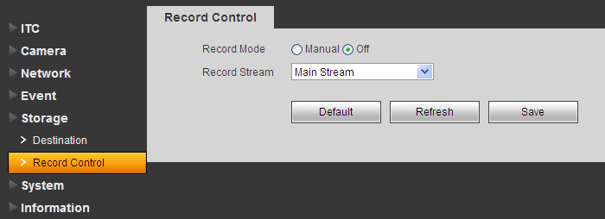
Figure 5-35

System
System supports config of local info, user, default settings, and import/export config file.

General

General
Select Setup>System>General.
The general interface is shown as in Figure 5-36.
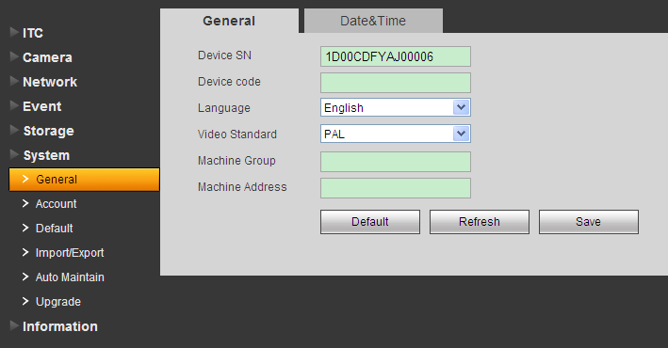
Figure 5-36

Please refer to the following sheet for log parameter information.
Parameter | Function
Device SN | Set device SN.
Device No. | Fill in device mark.
Language | Select language and then close IE. When you log in again, system language will change.
Video standard | Display device video standard, such as PAL.
Machine Group | Fill in device organization name.
Machine Address | Fill in snapshot address.
Chart 5-16

Date&Time
Select Setup>System>Date&Time.
The date&time interface is shown as in Figure 5-37.
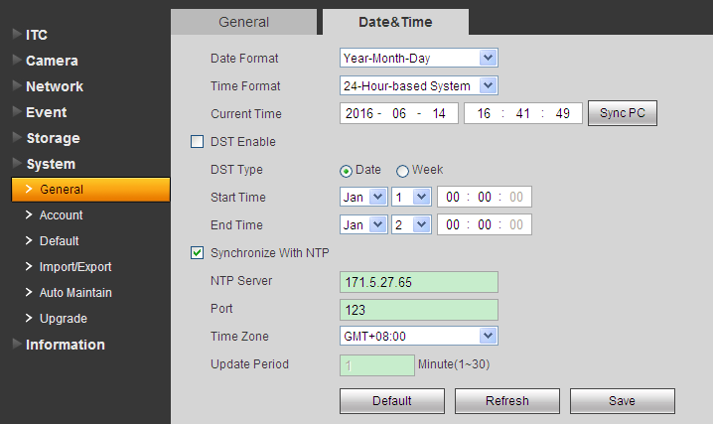
Figure 5-37
Please refer to the following sheet for log parameter information.
Parameter | Function
Date format | Select date format.
Time format | Select time format.
Current time | Set current system time. Setup becomes effective immediately.
Sync PC | Sync system time with PC time. Click on save to refresh system time.
DST | Set DST, may by date or week. Setup becomes effective immediately.
NTP setup | Check to sync with NTP.
NTP server | Set NTP server address.
Port | Set NTP port no.
Time zone | Set device time zone.
Update period | Set device update period.
Chart 5-17

Account
System supports to config WEB user, and before configuring user, you must config user group first.

Account
Select Setup>System>Account>Username.
The account interface is shown as in Figure 5-38. Here you can add and delete username, and modify user password.

Add user box is in Figure 5-39.

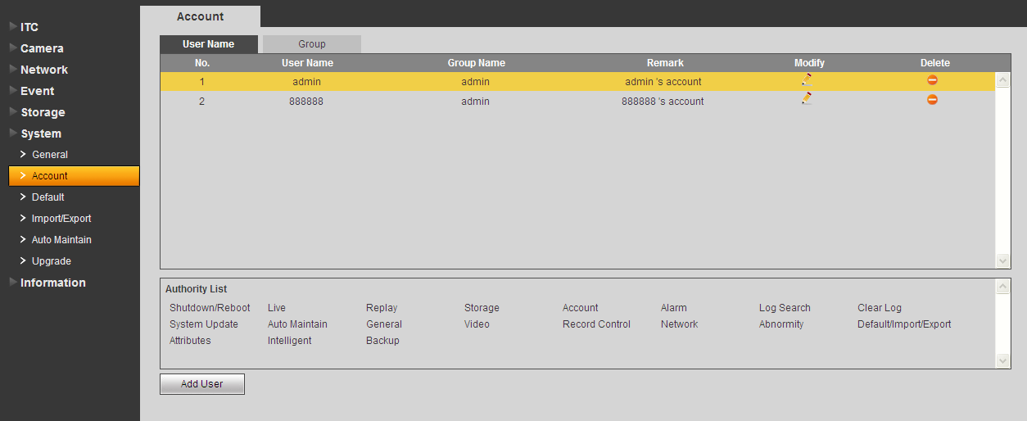
Figure 5-38
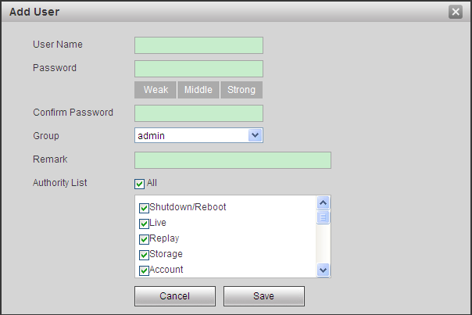
Figure 5-39
The system supports up to 18 users.
- Add user: Add user within group and set user right.
- Modify user: Modify existing user’s group, password, right and note.
- Modify password: Modify password of existing user. Check box in front of modify password. Input current password and then input new password. Click on save. Password supports 0~15 characters, including letter and number only.
Note:
- You cannot modify right of the logged in account.
- You cannot modify or delete admin, 888888 and 666666 accounts.
- Account who has right to modify other account, can modify other user account besides its own.
- You cannot delete currently logged in account.

Anonymous login: Enable anonymous login as input IP without username and password to log in device. This type of account only have preview right. You may switch to other account by clicking on logout.

Group
The system supports add up to 8 user groups, and initial user groups are “admin” and “user.
The group interface is shown as in Figure 5-40. Here you can add and delete group, and modify group password.
- Select Setup>System>Account>Group.
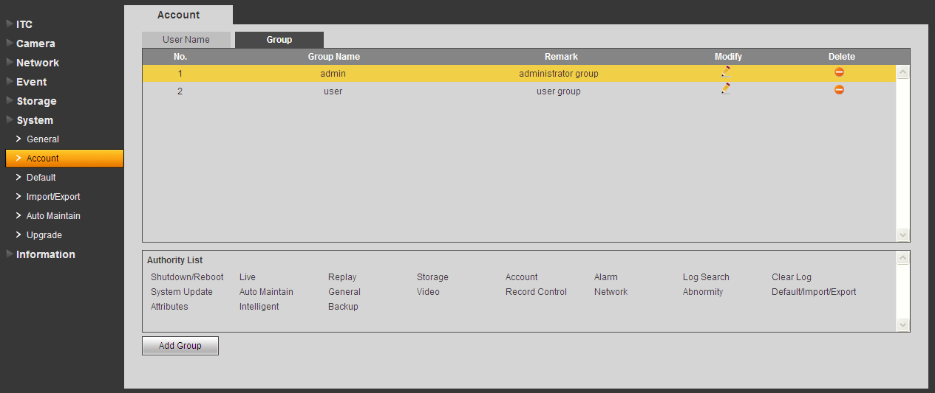
Figure 5-40
- Click. See Figure 5-41.
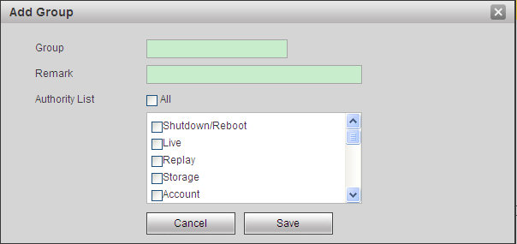
Figure 5-41
- Fill in group name and set right.
Note:
- Group only contains letter, number, underline and dash up to 15 characters.
- User group cannot be repeated.
- Click Save.
- You can modify and delete existing user group, but you cannot delete default user groups.

Default
The default interface is shown as in Figure 5-42.
Select Setup>System>Default.
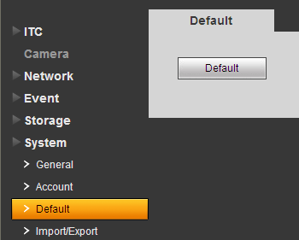
Figure 5-42

Note: Network IP address cannot be restored to default.

Import/Export
The import/export interface is shown as in Figure 5-43.
- Select Setup>System>Import/Export.
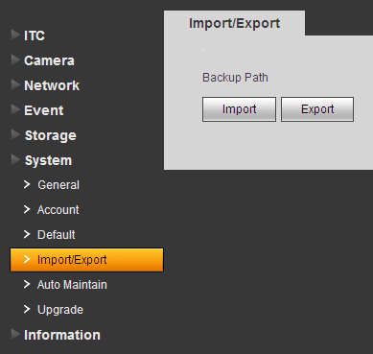
Figure 5-43
- Click Import or Export.
  - Import: import local backup of config file into the system.
  - Export: export config to local, save as “.backup” file.
- Select file path of file you want to import or export.

Auto Maintain
Select Setup>System>Auto Maintain.
The auto maintains interface is shown as in Figure 5-44.

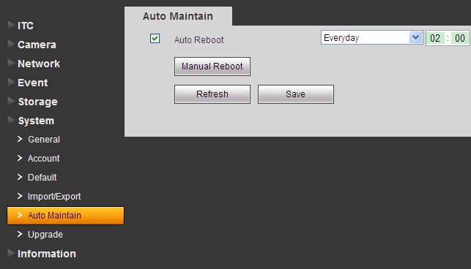
Figure 5-44

Parameter | Note
Auto Reboot | System will reboot at set time.  Check it and set reboot cycle and time.
Manual Reboot | Manually reboot device.

Upgrade
Select Setup>System>Upgrade.
When system upgrades, you shall select firmware file. Firmware file ends in *bin. Please maintain stable power supply, connection and do not reboot or shut down camera during this process.
The upgrade interface is shown as in Figure 5-45.

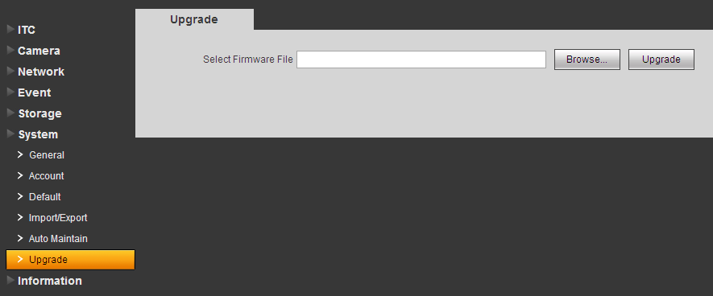
Figure 5-45

Note: If system encounters error during upgrading, the device may malfunction.

Information
Here you can view system version, user, log and etc.

Version
Select Setup>System>Version.
The version interface is shown as in Figure 5-46.

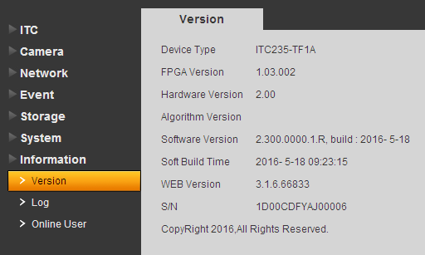
Figure 5-46

Log
The log interface is shown as in Figure 5-47.
System supports to search and back up log by time, type and other criteria. Log type includes system operation, config anf etc.
- Select Setup>System>Log.
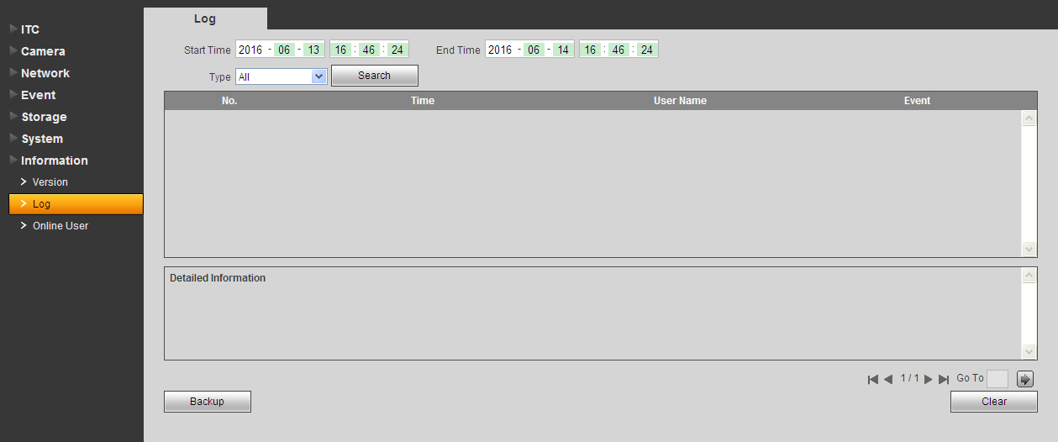
Figure 5-47
- Enter start time and end time, select log type.
- Click Search.
- You can view, back up and clear results.
- Clear: Clear all system log displayed. You cannot clear log by type.
- Backup: Create backup of displayed log onto current used PC.

Online User
The online user interface is shown as in Figure 5-48.Here displays online user and their group, IP address and login time.
Select Setup>System>Online User.

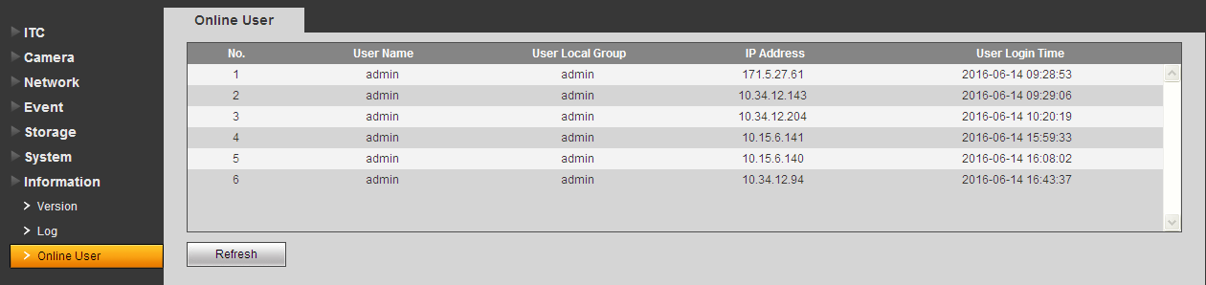
Figure 5-48

Alarm
In web page, open alarm on main menu. It is to set device alarm type and tone.
The alarm interface is shown as in Figure 6-1.
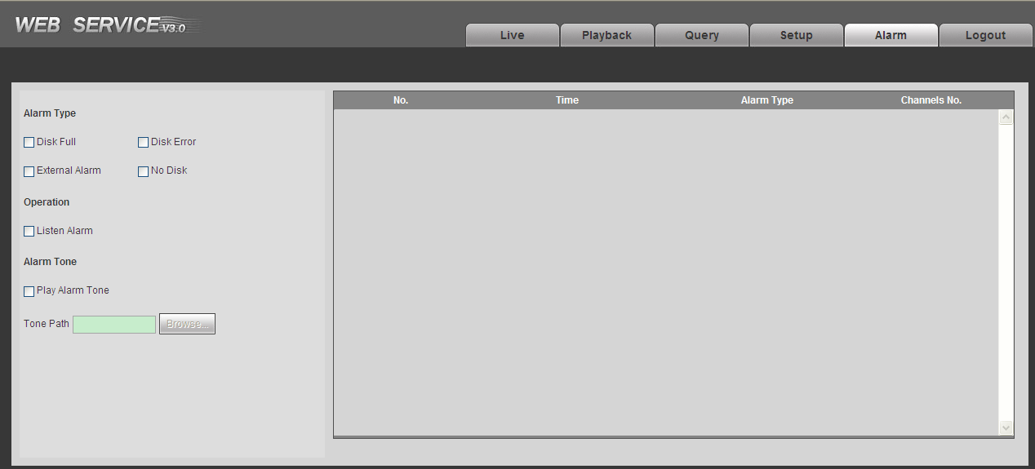
Figure 6-1
Please refer to the following sheet for log parameter information.
Type | Parameter | Function
Alarm type | Disk full | Alarm when disk is full.
Alarm type | Disk error | Alarm when disk error occurs.
Alarm type | External alarm | Alarm when external alarm is imported into device.
Alarm type | No disk | Alarm when there is no disk.
Operation | Listen alarm | When there is alarm in device, device will inform users via WEB.
Alarm tone | Play alarm tone | Alarm with tone. You can customize it.
Alarm tone | Tone path | Select tone path.

Logout
Single click on logout to exit WEB interface. You will see Figure 7-1.To return web interface, you have to log in again.

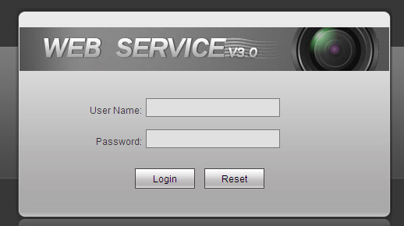
Figure 7-1

Note:
- This manual is for reference only. Slight difference may be found in the user interface.
- All the designs and software here are subject to change without prior written notice.
- All trademarks and registered trademarks mentioned are the properties of their respective owners.
- If there is any uncertainty or controversy, please refer to the final explanation of us.
- Please visit our website or contact your local retailer for more information.

