Flow Analytics Camera User’s Manual

Version 1.0.1

Welcome
Thank you for purchasing our camera!
This user’s manual is designed to be a reference tool for your system.
Please read the following safeguard and warnings carefully before you use this series product!
Please keep this user’s manual well for future reference!

Important Safeguards and Warnings
1．Electrical safety
All installation and operation here should conform to your local electrical safety codes.
The power shall conform to the requirement in the SELV (Safety Extra Low Voltage) and the Limited power source is rated 90-240V.
We assume no liability or responsibility for all the fires or electrical shock caused by improper handling or installation.

2．Transportation security
Heavy stress, violent vibration or water splash are not allowed during transportation, storage and installation.
Please keep package material well in case you need to send it back to your local retailer or manufacturer for maintenance work.
Non-original package material may result in device damage during the transportation.

3．Installation
Do not apply power to the camera before completing installation.
Please install the proper power cut-off device during the installation connection in case there is any emergency situation.
Always follow the instruction guide the manufacturer recommended.

4．Qualified engineers needed
Do not replace the button cell on the internal circuit of the main board without the prior authorization. Improper button cell type may result in risk of explosive.
Please process the used button cells properly according to its usage instruction.
All the examination and repair work should be done by the qualified service engineers.
We are not liable for any problems caused by unauthorized modifications or attempted repair.

5．Environment
This series camera should be installed in a cool, dry place away from direct sunlight or strong light, inflammable, explosive substances and etc.
The working temperature ranges from -20℃ ~ to +70℃. Do not touch the external metal part of the device when it is working in harsh environments.
Please keep it away from the electromagnetic radiation object and environment.
Please keep the sound ventilation.
Do not allow the water and other liquid falling into the camera.
Usually we recommend thunder-proof device to prevent thunder strike.
The GND port of the product shall be grounded to further enhance the reliability of the device.

7. Daily Maintenance
Please shut down the device and then unplug the power cable before you begin daily maintenance work.
Use the dry soft cloth to clean the device.
If there is too much dust, please use the water to dilute the mild detergent first and then use it to clean the device. Finally use the dry cloth to clean the device.

8. Accessories
Be sure to use all the accessories recommended by manufacturer.
Before installation, please open the package and check all the components are included.
Contact your local retailer ASAP if something is broken in your package.
You may install the device if nothing is missing or broken in your package.

Table of Contents
1 General Introduction 1
1.1 Overview 1
1.2 Features 1
2 Framework 3
2.1 Rear Panel 3
2.2 Side Panel 4
2.3 Front Panel 5
3 Device Installation 6
3.1 Install Lens 6
3.1.1 Install Auto Iris Lens 6
3.1.2 Install Manual Iris Lens 6
3.1.3 Remove Lens 6
3.2 Install SD Card 7
3.2.1 Installation 7
3.2.2 Remove 7
3.3 I/O Port 8
3.3.1 Install Cable 8
3.3.2 Remove Cable 9
4 System Network 10
5 Quick Configuration Tool 11
6 Web Operation 14
6.1 Login 14
6.1.1 Network Connection 14
6.1.2 Login and Homepage 14
6.2 Config Alarm 15
6.2.1 Alarm Connection 15
7 FAQ 18

General Introduction

Overview
Flow Analytics Camera as the core surveillance equipment of road monitoring system, with embedded operating systems, advanced compression technology H.264 encoding, and flexible snapshot.
The product monitors different roads, and sends video data via network to client, server, back-end storage devices for unified management.
The product is widely used in road security surveillance system, which effectively records vehicle flow data and provides an effective management tool for modern traffic management.

Features
Snap Mosaic | - Snapshot vehicle picture and meantime cutoff one picture of plate.
Intelligent Recognition | - Support plates, logo, cars, body color and model recognition.  - Support pressure line, retrograde, speeding, not wearing a seatbelt and other illegal detection.
User Management | - Different user rights for each group and you may modify the setup anytime.  - Search online user info.
Log Management | - Support 1024 log.  - Support account right setup.
Storage  Function | - Support record via Web and the recorded file are storage in the client-end PC.  - Support hot swap SD card storage function. Support short-time storage function when encounter offline problem. Support auto overwrite function. Please note SD card can only storage the image.
Alarm Function | - For camera abnormity, it can send alarm via network, such as storage damage.  - Real-time respond to external alarm input( within 200MS) as user pre-defined activation setup and exert corresponding message in screen and audio prompt(allow user to pre-record audio file).
Network Monitor | - Camera supports one-channel A/V data transmit to network terminal and then decode. Allowed by the band width, delay is less than 500ms.  - Max supports 10 connections.  - Adopt the following transmission protocol: HTTP, TCP, UDP, MULTICAST and RTP/RTCP and etc.  - Support web access, widely used in WAN.
Traffic Statistics | - Matching with traffic signal controller, output vehicle in signal and out signal.  - Within set period, support statistics of flow, time occupancy, head distance, line length and etc.
Snapshot | - Support picture snapshot and encode. Support watermark encryption to avoid the vicious modification.  - Snapshot can auto record vehicle info such as time.
OSD Setup | - Set OSD info and position of video channel, picture and snapshot mosaic.
Network Management | - Realize camera configuration and management via Ethernet.  - Support device management via web.
Peripheral Equipment | - Support peripheral equipment management, each peripheral equipment control protocol and interface can be set freely.  - Support activation devices such as flashlight, strobe light, vehicle detector, radar device and etc.
Power Supplying | - Support DC 12V input.
White Balance | - Auto White Balance: When the light changed, the situation is still able to accurately reflect the color of the subject.  - Local white balance: Referring to the surrounding environment, adjusting the color of the subject case.
Auto Exposure | - System can automatically set shutter speed and iris value according to the snapshot video exposure condition.
Auto Gain | - To output the standard video signal in the different illumination environments, the amplifier needs to adjust in a wide range. The system can enhance the camera sensitivity in low illumination and enhance the video signal output to get the clear and high definition video.
Assistant Function | - Support video watermark function to avoid vicious video modification.  - Support system resource information and running status real-time display. Support log function.  - Support flashing light signal control and output

Framework

Rear Panel
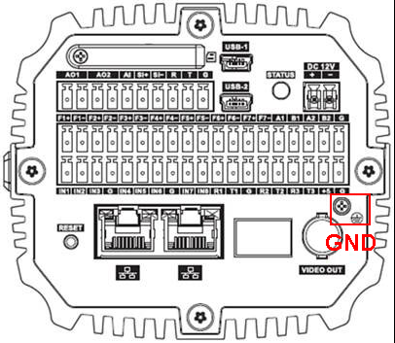
Figure 2- 1
Port Name |  | Function
SD | SD card port | Connecting SD card. SD card usage:  - When installing SD card, make sure SD card is not write-protected and then inserted into the SD card slot.  - When  remove the SD card, make sure the SD card reader is not in read/write state, it may cause data loss and damage to the SD card.  - When hot-swap the SD card, please stop recording after the operation.
AO1, AO2 | 2-ch alarm output | May config as alarm output port and rain brush output port.
AI | Alarm input port | As alarm input port, receive external alarm source switch signal.
SI+, SI- | External frequency same-source sync input port | Camera sync external signal source（select external sync option auto take effect, voltage range 12～36Vp-p or AC 12V～AC 24V）.
R | RS232 serial | RS232_RX，RS232 serial receiver.
T | RS232 serial | RS232_TX，RS232 serial sender.
G | GND | GND
STATUS | Indicator | Used to indicate the status of the camera work. Working status indicator as follows:  After the system is powered for the red light goes off after about changes to blue light, this time that the application is running, you can log in through the network.  Status light will turn off when the system is restarted.  - Blue flashing (reserved): video.  - Red flashing: software upgrade.  - Long red flashing: in safe mode.
RESET | Reset | Restore the device to factory default settings. Equipment under normal operating conditions (power indicator is blue), press and hold this button after more than five seconds, the system configuration information to restore to factory default settings.
DC 12V | - | Power port, may input 12V DC.
F1+, F1-, F2+, F2-, F3+, F3-, F4+, F4-, F5+, F5-, F6+, F6- , F7+, F7- | 7-ch output ports | Switch, may config flashlight output signal and strobe light output signal.
A1 | RS485 port | RS485_A1 port, external signal detector, vehicle detector.
B1 | RS485 port | RS485_B1 port, external signal detector, vehicle detector.
A2 | RS485 port | RS485_A2 port, external signal detector, vehicle detector.
B2 | RS485 port | RS485_B2 port, external signal detector, vehicle detector.
 | GND port | During customers use of the device, the interface is connected to the ground to avoid being struck by lightning and other equipment problems.
IN1, IN2, IN3, IN4, IN5, IN6, IN7, IN8 | IO input port | Provide 8 IO trigger snapshot ports.
R1 T1 G  R2 T2 G  R3 T3 G | 3-ch radar port | Provide 3 radar sync input ports.
+5 | - | Power supply for low power 2W device
USB1/USB2 | 2 USB ports | Extend for 3G and Wifi.
 | 2 network ports | Connect to standard Ethernet
VIDEO OUT | Video output BNC | BNC（1.0Vp-p，75Ω）

Side Panel
Side panel dimensions are L*W*H= 170.5mm×96mm×85mm. See Figure 2- 2.
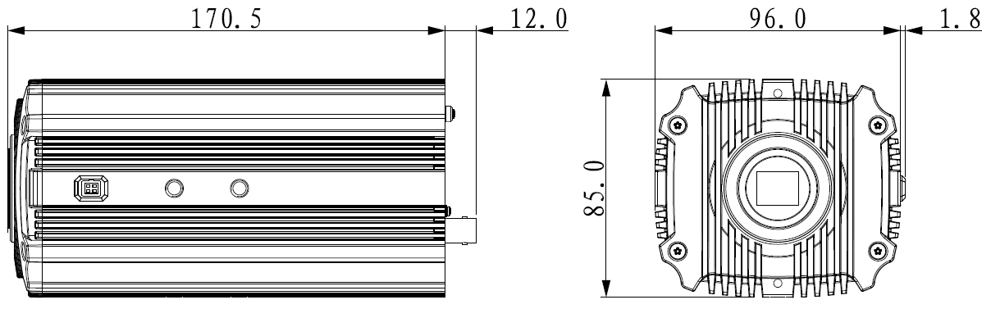
Figure 2- 2

Front Panel
Figure 2- 3

Device Installation

Install Lens
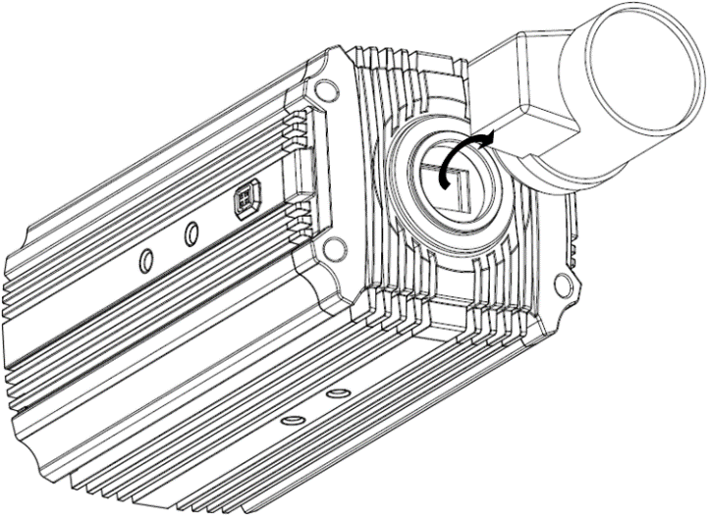
Figure 3- 1

Install Auto Iris Lens
- Remove CMOS cover on device, aim the lens at installation position. Clockwise rotate the lens until it is installed in place.
- Insert lends cable into the auto iris connected on side panel of camera.
- Adjust focus to make image clear.

Install Manual Iris Lens
- Remove CMOS cover on device, use cross screwdriver to unfasten the screw on focusing ring, and counterclockwise rotate the ring for several mm to manually adjust focus.
- Fasten screw with cross screwdriver, fix focusing ring.
- Aim the lens at installation position. Clockwise rotate the lens until it is installed in place.

Remove Lens
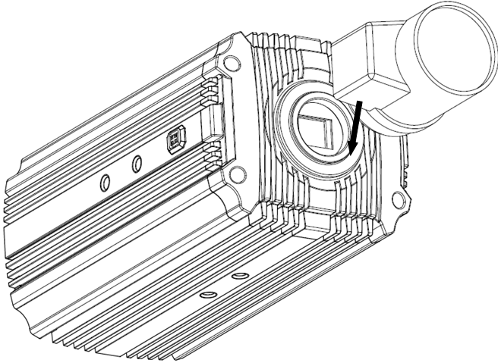
Figure 3- 2
- Take down auto iris lens cable from auto iris lens connector. If it is manual iris lens, please skip step 1.
- Counterclockwise rotate the lens, until you can remove it.
- You can put on CMOS cover for protection.

Install SD Card

Installation
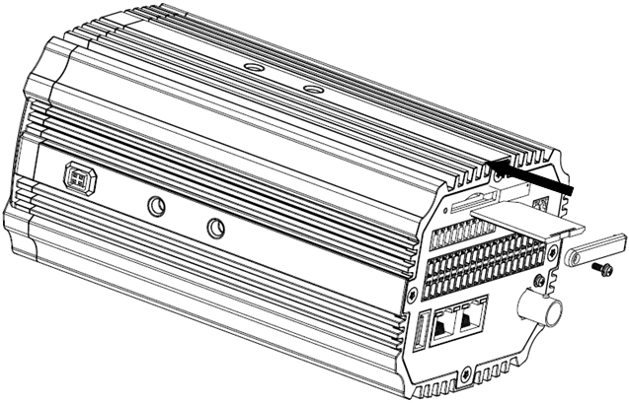
Figure 3- 3
- Unfasten SD card cover on rear panel with screwdriver. Take down the SD card cover.
- Insert SD card into device along the direction of SD card installation.
- Put back SD card cover.
- Fasten SD card cover with screwdriver to fix it on device.

Remove
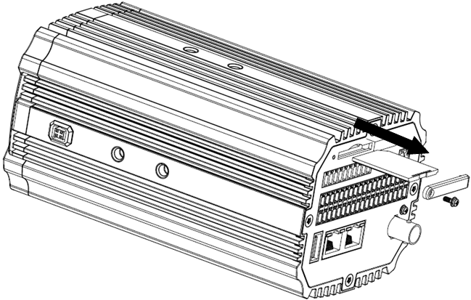
Figure 3- 4

- Unfasten SD card cover on rear panel with screwdriver. Take down the SD card cover.
- Take out SD card into device along the direction of SD card installation.
- Put back SD card cover.
- Fasten SD card cover with screwdriver to fix it on device.

I/O Port

Install Cable
Warning:
To ensure device grounding is right and improve device reliability, connect device port to the ground.

Figure 3- 5
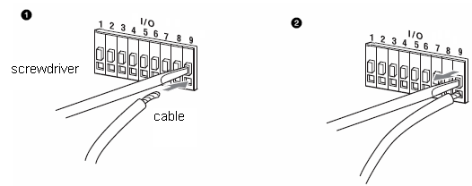
Figure 3- 6

- Use a small straight screwdriver to press the slot button corresponding to the cable you want to connect.
- Insert cable into the slot hole.
- Release the screwdriver that hold the slot.

Remove Cable
- Use a small straight screwdriver to press the slot button corresponding to the cable you want to connect.
- Pull out the cable from hole.
- Release the screwdriver that hold the slot.

System Network
Please refer to Figure 4-1 for system connection.
Video detector Client-end
Centre server
…… Camera
Flash light ……
Storage device
……
Figure 4-1

Quick Configuration Tool
Quick configuration tool can search current IP address, modify IP address. At the same time, you can use it to upgrade the device.
Double click the “DH_ConfigTool.exe”icon, you can see an interface is shown as in Figure 5- 1.
In the device list interface, you can view device IP address, port number, subnet mask, default gateway, MAC address and etc.
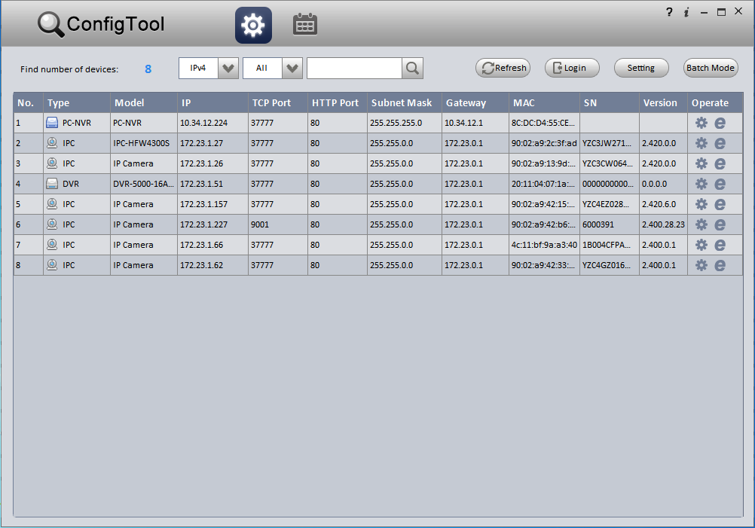
Figure 5- 1
In Quick Config Tool, you can operate:
- Click in device row, to login WEB page. See Figure 5- 2.
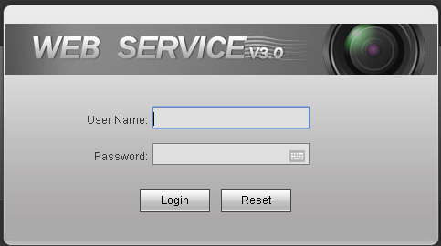
Figure 5- 2
- Double click in a certain row or at the end of row, to login Quick Config Tool page. Here you can set video, net, encode and etc. See Figure 5- 3.
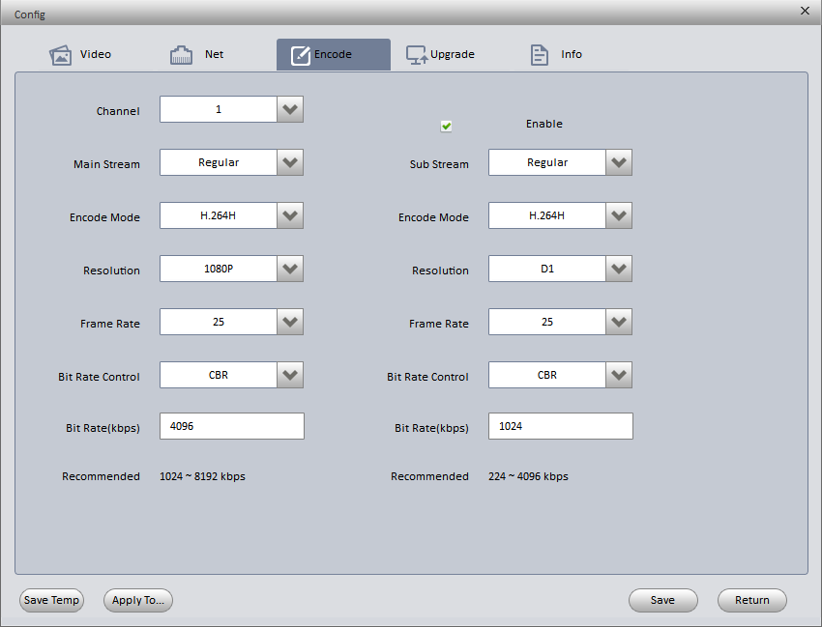
Figure 5- 3
- Click 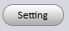, to search device. See Figure 5- 4.
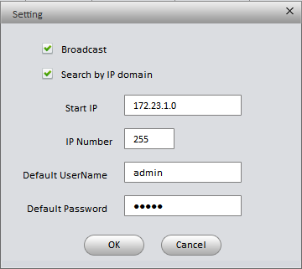
Figure 5- 4
- Broadcast: after you check it, search device in the same segment with current PC.
- Search by IP segment: after you check it, according to start IP and IP quantity search device.
- Click 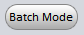 to batch config and upgrade device. See Figure 5- 5.
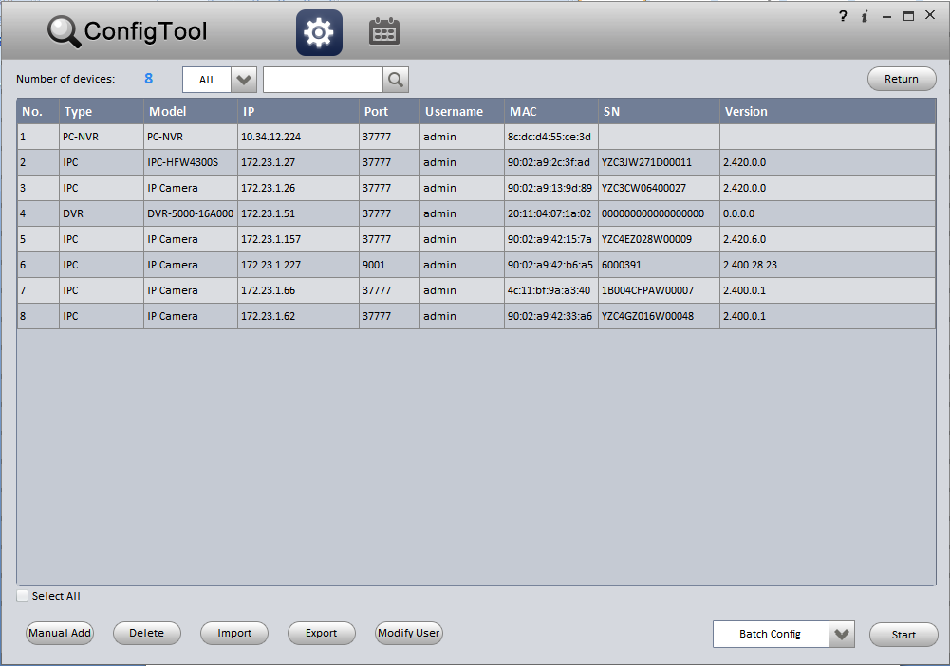
Figure 5- 5

For detailed information and operation instruction of the quick configuration tool, please refer to the Quick Configuration Tool User’s Manual included in the resources CD.

Web Operation
This series camera product supports the Web access and management via PC.
Web client provides preview, playback, search, settings, alarm and logout modules.

Login

Network Connection
Please follow the steps listed below for network connection.
- Make sure the camera has connected to the network properly.
- Camera IP address and PC IP address shall be in the same network segment. If there is router, please set the corresponding gateway and subnet mask.
The device supports dual Ethernet cards, card 1 default IP is 192.168.1.108 and card 2 default IP is 192.168.0.108.
- Use order ping ***.***.***.***(* camera address) to check connection is OK or not.

Login and Homepage

- Open Internet Explorer, input the IP address of device.
Note:
When you login for the first time, system will prompt you to install or load control unit.
- Click Install.
System will automatically recognize this control unit. Later version WEB system will automatically cover old versions of WEB.
- In the WEB interface, input username and password (Default username and password are both: admin), click Login. See Figure 6- 1.
Figure 6- 1
- Please change your password after you have successfully login for the first time.
- You can change password according to the password strength level. Click OK when you are done, or click Cancel when you want to exit without modifying current password.
The homepage is shown in Figure 6- 2.
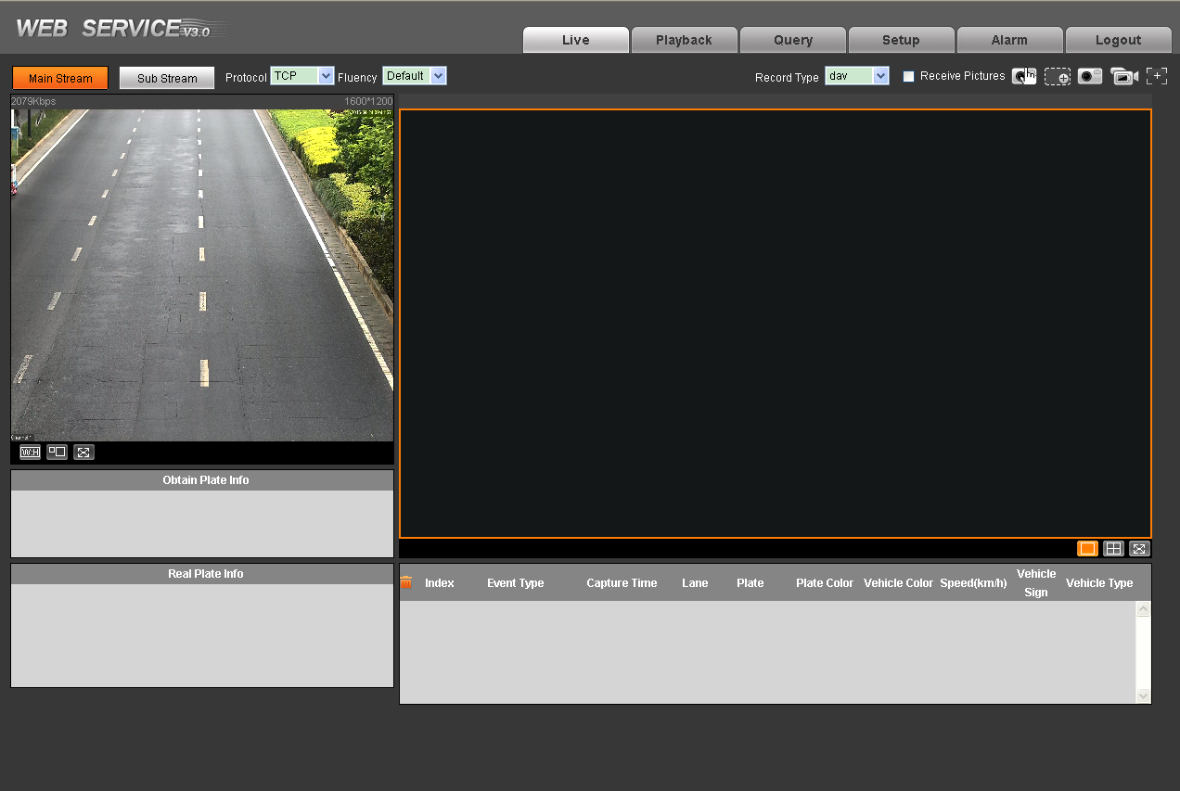
Figure 6- 2
Please refer to the Web Operation Manual included in the resource CD for detailed operation instruction.

Config Alarm

Alarm Connection
- Connect alarm input device to alarm input port on rear panel.
- Connect alarm output device to alarm output port on rear panel. Alarm output port supports connection of NO alarm devices.
- Open WEB, set alarm input and output in Alarm settings.
Alarm input on WEB corresponds to alarm input at rear of device.
According to signal level of alarm input device when alarm occurs, set matching NO/NC input.
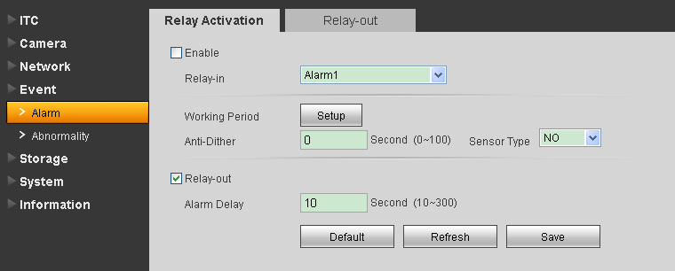
Figure 6- 3
- On WEB, set alarm output. Here alarm output corresponds to alarm output at rear of device.
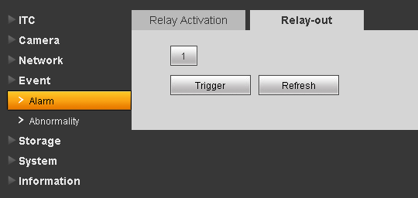
Figure 6- 4
- On WEB, set alarm prompt type and sound. When alarm occurs, system will trigger configured alarm action.
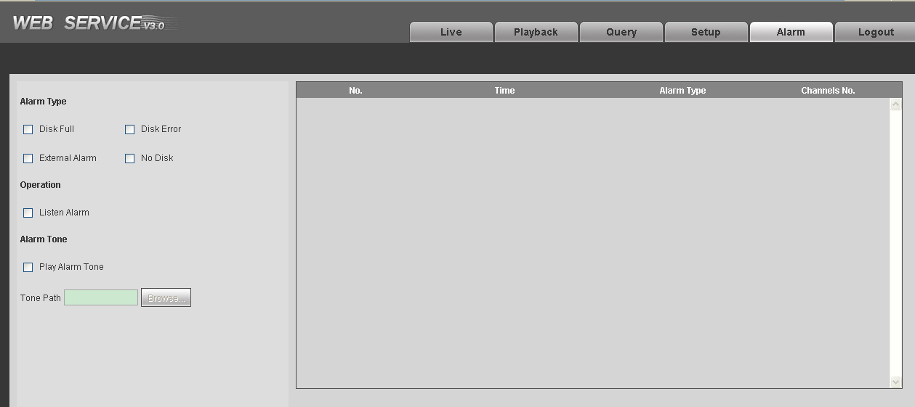
Figure 6- 5

FAQ
Bug
I cannot boot up the device. | Please click RESET button for at least five seconds to restore factory default setup.
SD card hot swap | Before draw out SD card, please stop record or snapshot first and then wait for at least 15 seconds to remove the SD card.  All the operations before is to maintain data integrity.
SD card write times | Do not set the SD card as the storage media to storage the schedule record file. It may damage the SD card duration.
I cannot use the disk as the storage media. | When disk information is shown as hibernation or capacity is 0, please format it first (Via Web).
I cannot upgrade the device via network. | The status indication light is shown as red when network upgrade operation failed. You can use port 3800 to continue upgrade.
Recommended SD card brand | Kingston 4GB, Kingston 1GB, Kingston 16GB, Transcend 16GB, SanDisk 1G, SanDisk 4G  Usually we recommend the 4GB (or higher) high speed card in case the slow speed results in data loss.
Web control webrec.cab not pop up | Please set IE security level to low and enable ActiveX plug-in.

Note:
- This manual is for reference only. Slight difference may be found in the user interface.
- All the designs and software here are subject to change without prior written notice.
- All trademarks and registered trademarks mentioned are the properties of their respective owners.
- If there is any uncertainty or controversy, please refer to the final explanation of us.
- Please visit our website or contact your local retailer for more information.

