Fast operation of IP Villa System

V1.0

- System Structure
Power for VTO is DC12V/1A, power for Dahua switch is DC24V
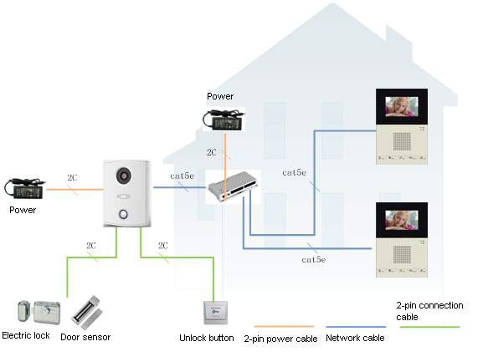
Figure 1-1
- Operation Steps
VTO--- The default IP of VTO is 10.22.5.189, and the project setting password is #888888#;
VTH--- The default IP of VTH is 10.22.5.180, and the project setting password is 002236;
Note:
When you want to connect the devices, please make sure the IP address of VTO and VTH are in the same network segment.
2.1 VTO WEB Config
Filled in the VTO’ IP address in the IE explorer, it will show a log interface as Figure 2-1, account/password are admin/admin.
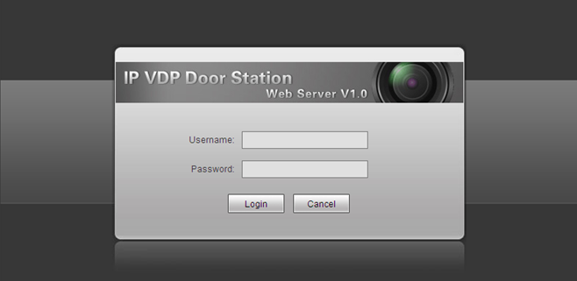
Figure 2-1
Basic Configuration:
Step 1 Check system Config>Local Config> set Video Format into WVGA, see Figure 2-2
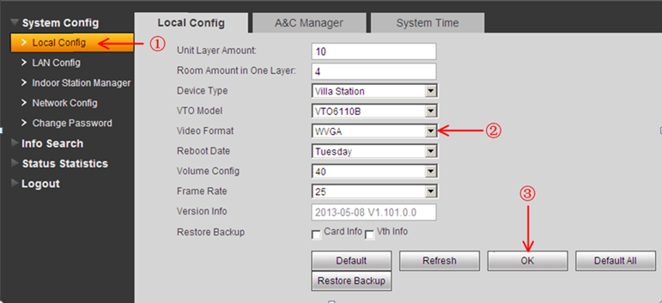
Figure 2-2
Step 2 Check Indoor Station Manager, click on Add to add one VTH Short No., such as: 102. See Figure 2-3.
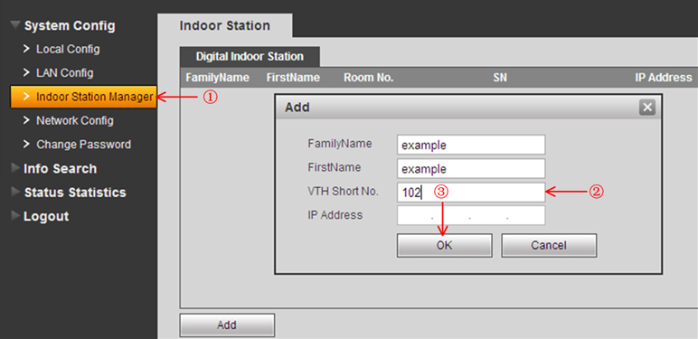
Figure 2-3
  - Main VTH Setup
On the VTH’s screen, please point Setting> Project Settings> 002236
Step 1 Check Product Info, set Room No.(it need be same with the VTH short No. in Figure 2-3), Local IP, Subnet Mask, Gateway, then point OK to save it . See Figure 2-4.
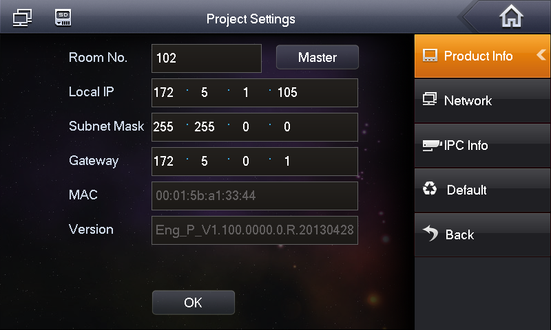
Figure 2-4
Step 2 Check Network, input main VTO IP in Network, then point ok to save it. See Figure 2-5.
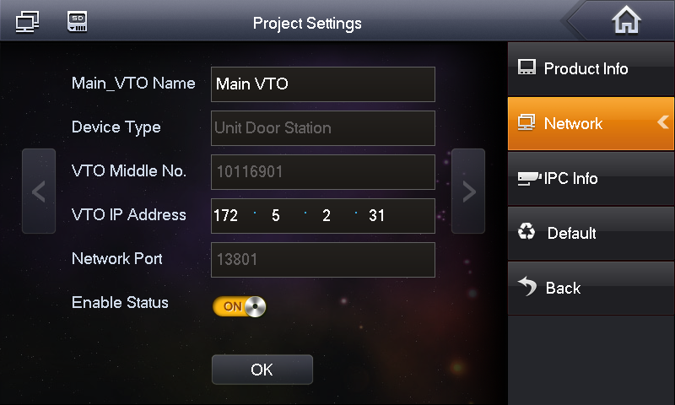
Figure 2-5
After the above operation steps, it can make a call from VTO and VTH.
- Group call Settings
If there are more than 2 VTH, you can set group call function of VDP.
3.1 VTO web config
Step1 Add Main VTH, enter the VTO’s WEB interface,check System Config>Indoor station manager, click Add button, you only need add the Main VTH’s Room No., such as 102.
If there is a test room number in the list, such as 9999 or 9901, please delete it.
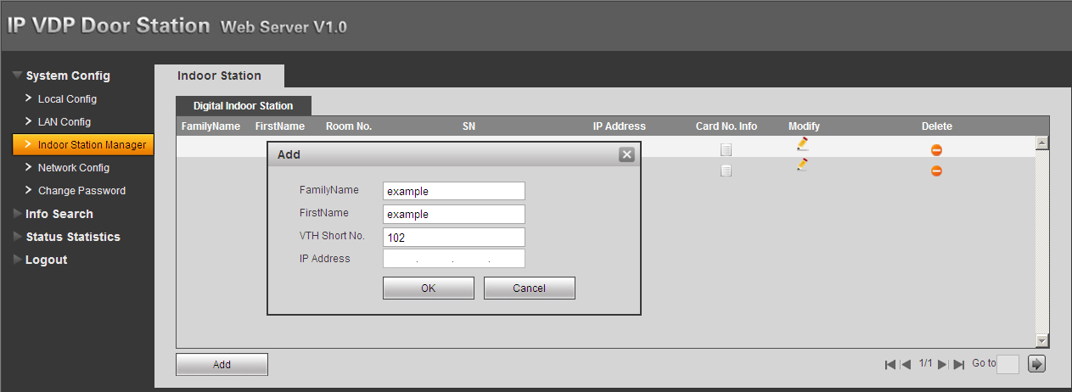
Figure 3-1
Step2 Please check System Config>LAN Config > check Group you need click OK button and restart Outdoor Station after setting up.
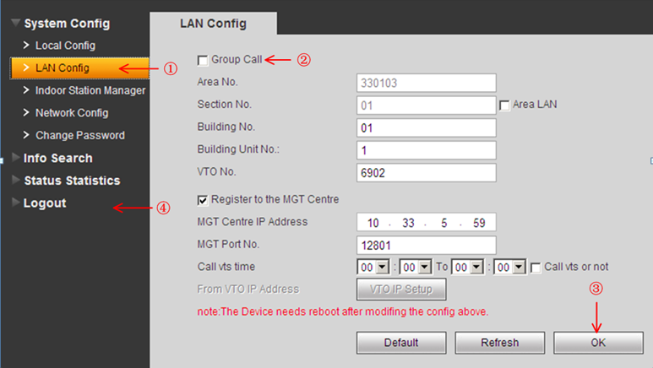
Figure 3-2
3.2 Sub- Indoor Monitor Settings
After setting main VTH(refer to 2.2), Similarly, enter Sub-Indoor Monitor’s Project Settings-Local Setting,
Step1 Check Master into Extension.
Step2 Input Room No. as 102-1, input the IP address of extension VTH.
Step3 Filled Master IP address, point OK to save it. After setting up, Sub-indoor Monitor will automatically synchronize with the Outdoor Station of main Indoor Monitor without other configuration. See figure 3-3
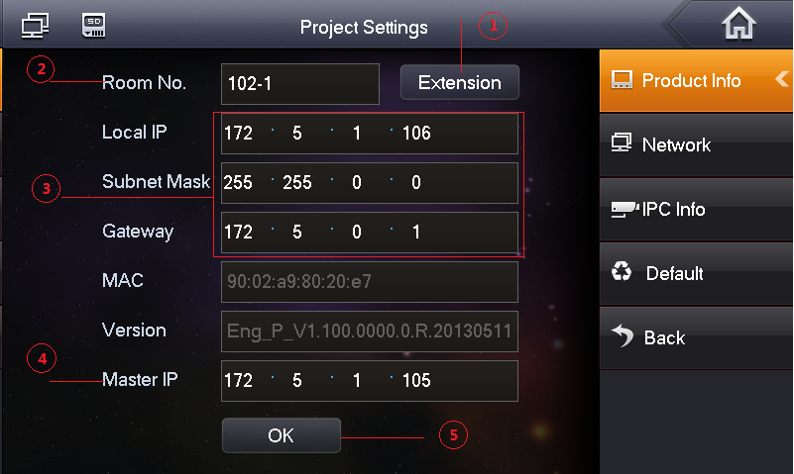
Figure 3-3
- Install lock and unlock button
4.1 VTO6100C
Definition of VTO6100C ports:

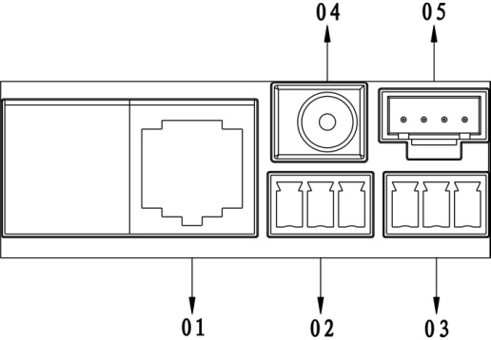
01. Network port: to external switch (IN port)
02. 3-pin 1: to lock control end 1
03. 3-pin 2: to lock control end 2
04. Power port: to input 12V DC power
05. Test port: to test device port
See Figure 4-1.

Figure 4-1
General types of lock in market are unlocking with power and unlocking without power. Here make electric lock and Magnetic lock as example.
4.1.1 Install electric lock

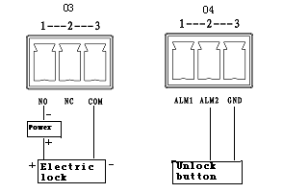
Figure 4-2

1. When connect VTO to electric lock, make electric lock + toward VTO NO-end (03.3-pin 1) and electric – toward VTO COM-end (03.3-pin 3).
2. When connect VTO to unlock button, make unlock button’s one end toward VTO (04. 3-pin 2) ALM 2-end and unlock button’s other end toward VTO (04.3-pin 3) GND-end.
See Figure 4-2.

4.1.2 Install Door sensor

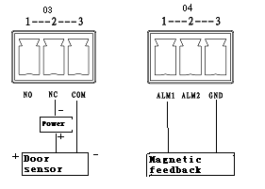
Figure 4-3

1. When connect VTO to door sensor, make door sensor + toward VTO (03.3-pin 2) NC-end and door sensor – toward VTO (03. 3-pin 3) COM-end.
2. When VTO is connected to door sensor for its magnetic feedback, make magnetic feedback’s end end toward VTO (04. 3-pin 1) ALM2-end to unlock and make magnetic feedback’s other end toward VTO (04. 3-pin 3) GND-end.
See Figure 4-3.
4.2 VTO6110B
Definition of VTO6110B ports:
VTH can be connected to any port on VTO.

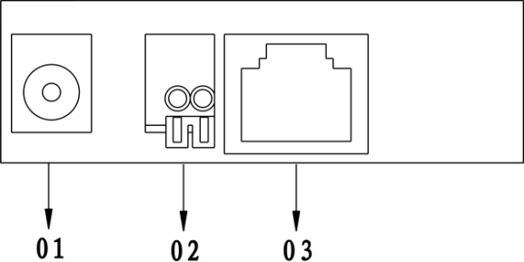
Figure 4- 4

01. Power port: to input DC 12V.
02. Lock port: to access control module
03. Network port: to switch (switch IN port)
See Figure 4-4.

Wiring function of access control extension module is shown as in 错误！未找到引用源。.
Access Control Extension Module Wiring Function
Group | Color | Function | Color | Function
4-Pin Cable A | Black | GND | Brown | Door sensor response
4-Pin Cable A | Orange | Alarm input | Yellow | Open button
3-Pin Cable  (Lock Control) | Grey | NC | Blue | Public port
3-Pin Cable  (Lock Control) | Purple | NO
4-Pin Cable B | Green | Door station,  cascading 485+ | Black | Power ground
4-Pin Cable B | White | Door station,  cascading 485- | Red | +12V
2-Pin Cable | Pink | Card-reader 485+
2-Pin Cable | Yellowgreen | Card-reader 485-

- Issue Card
The device supports IC card with frequency 13.56MHz.
Log in the VTO’s web interface, check System Config> Local Config> A&C Manager, web will inform you to swipe card on VTO device, take VTO6100C as an example. See Figure 5-1
After you swipe the card at the door station, click on OK. You will hear a short beep as the card is successfully issued.
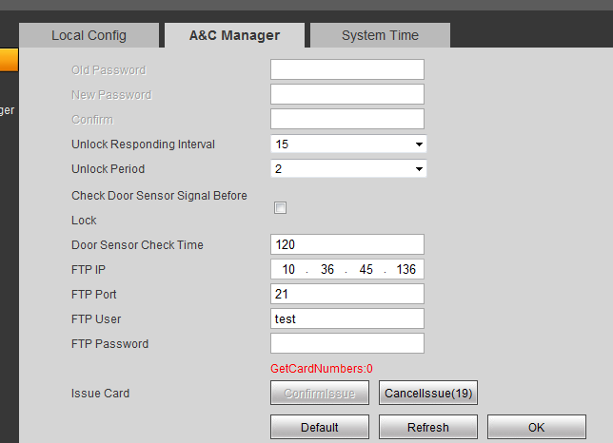
Figure 5-1

