Fast operation of Apartment System

- IP System (VTO12xxx)
1.1 system Structure
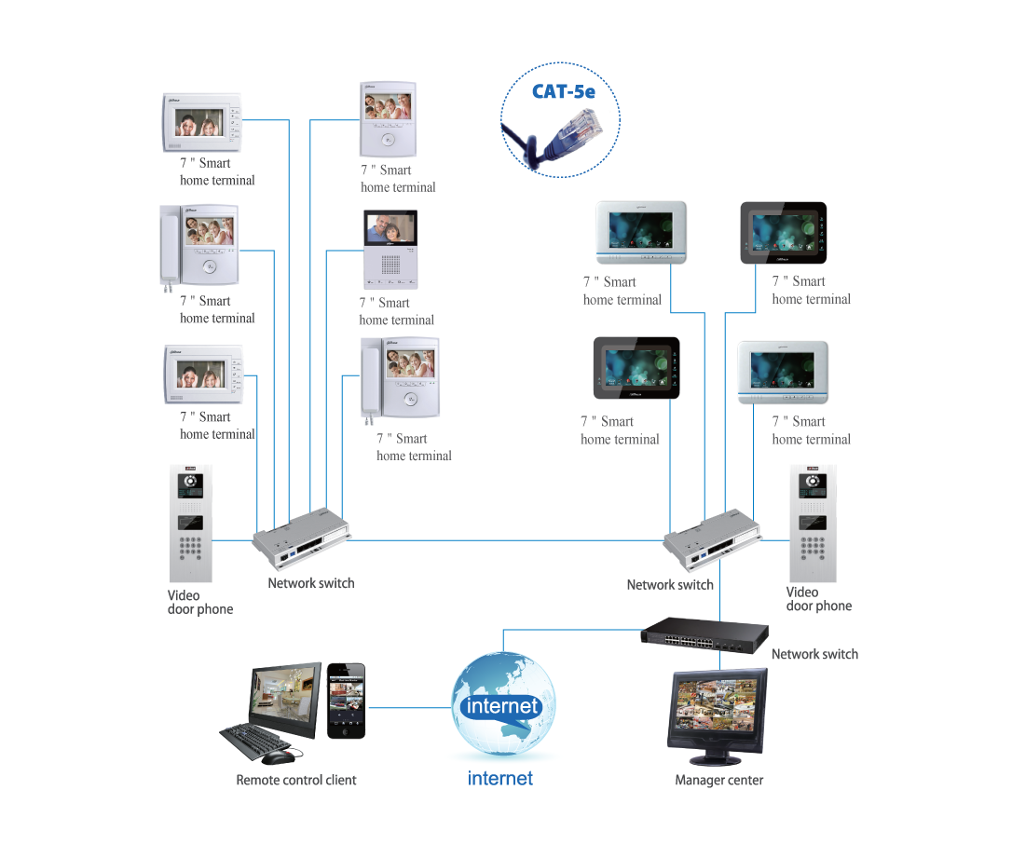
Figure 1-1
1.2 Operation Steps
VTO--- The default IP of VTO is 10.22.5.189, and the project setting password is #888888#;
VTH--- The default IP of VTH is 10.22.5.180, and the project setting password is 002236; all the other default passwords are 123456.
Note:
When you want to connect the devices, please make sure the IP address of VTO and VTH are in the same network segment.
1.2.1 VTO WEB Config
Filled in the VTO’ IP address in the IE explorer, it will show a log interface as Figure 2-1, account/password are admin/admin.
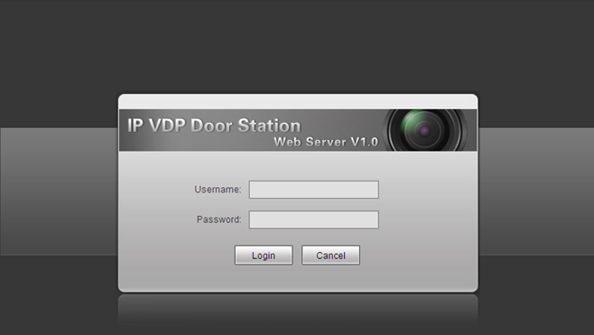
Figure 2-1
Basic Configuration:
Step 1 Check system Config>Local Config> set Video Format into WVGA, see Figure 2-2
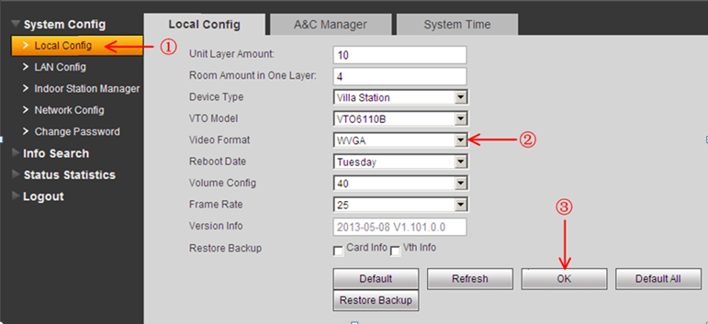
Figure 2-2
Step 2 Check Indoor Station Manager, click on Add to add one VTH Short No., such as: 102. See Figure 2-3.
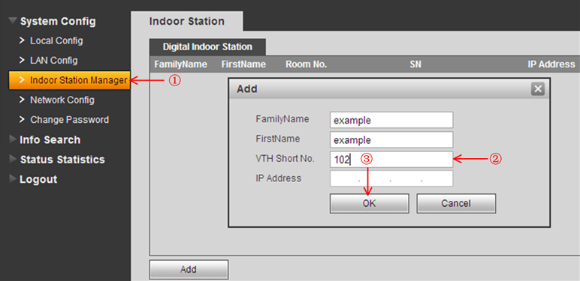
Figure 2-3
1.2.2 Main VTH Setup
On the VTH’s screen, please point Setting> Project Settings> 002236
Step 1 Check Product Info, set Room No.(it need be same with the VTH short No. in Figure 2-3), Local IP, Subnet Mask, Gateway, then point OK to save it . See Figure 2-4.
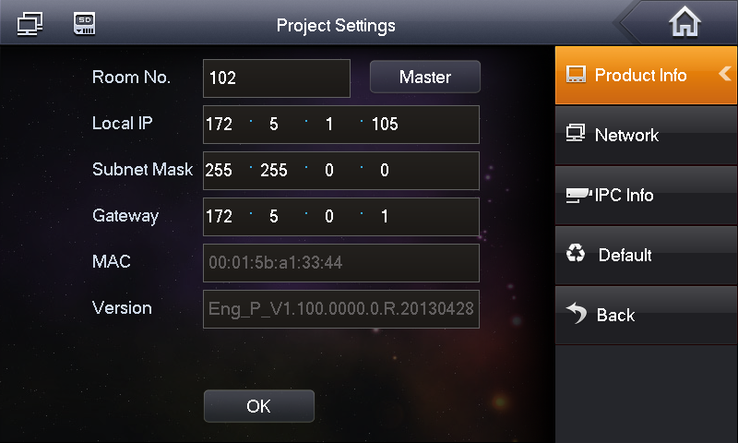
Figure 2-4
Step 2 Check Network, input main VTO IP in Network, then point ok to save it. See Figure 2-5.
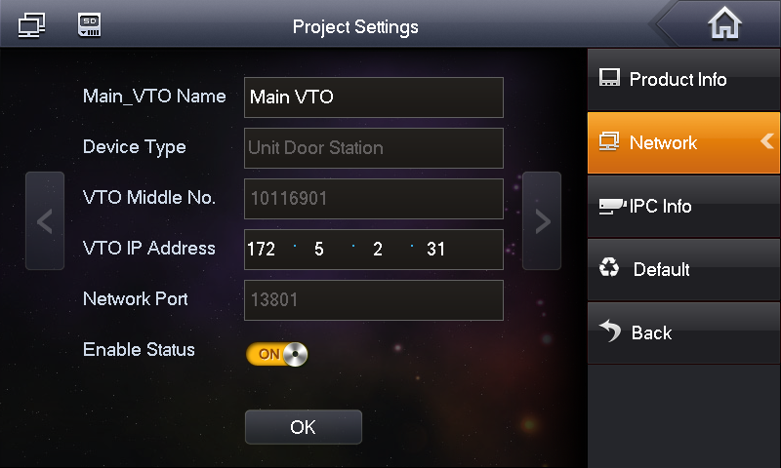
Figure 2-5
After the above operation steps, it can make a call from VTO and VTH.
- Analogue system
VTO1210A-X and VTO1210B-X can be applied in both IP and analogue system. the config steps in analogue system as blew:
2.1 System Structure
Figure 2-1
2.1.1 VTO1210A-X
Connect the device as Figure 2-2
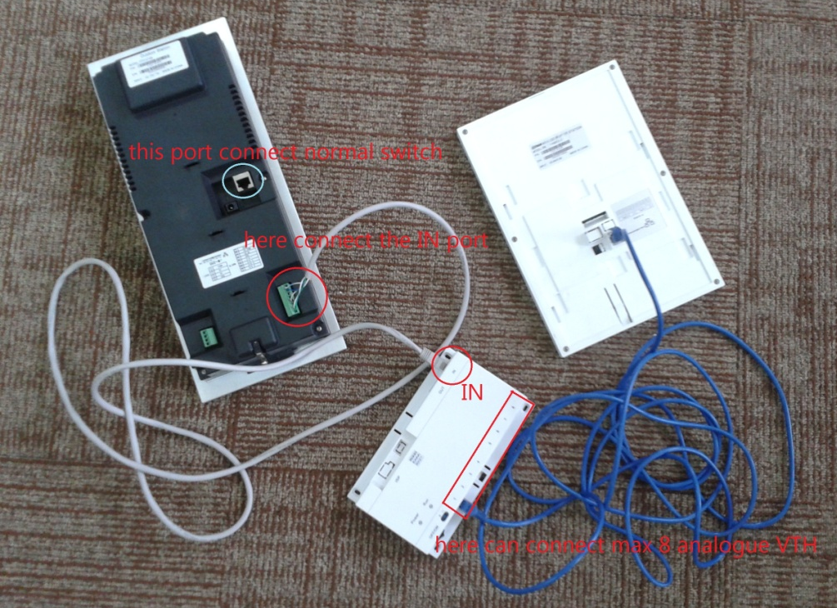
Figure 2-2
The ports of VTO1210A_X as Figure 2-3, For the port ③,the way to connect the net cable as Figure2- 4.
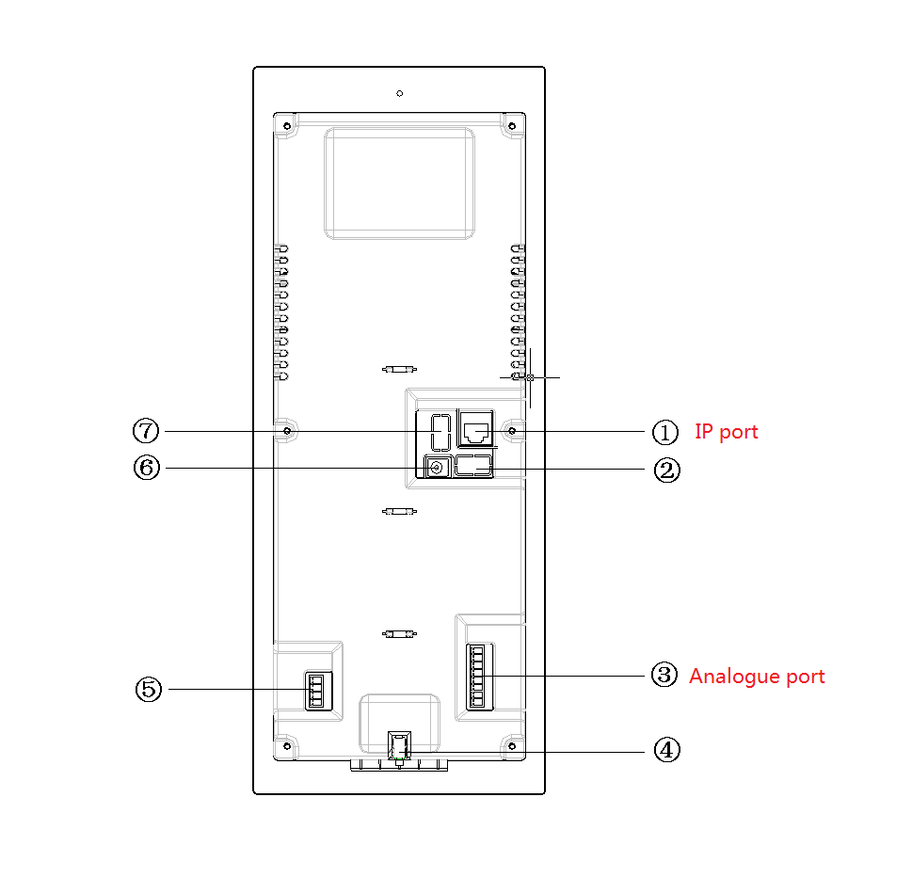

01. Vandal Proof Alarm Button
02. Network Port
03. Access Control Input Port
04. Power Port
05. Access Control Output Port
06. Analog Signal Port
07. RS485 Port

Figure 2-3
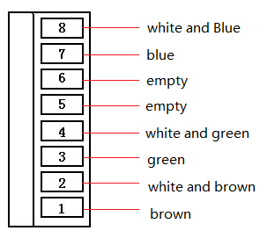
Figure 2-4
2.1.2 VTO1210B-X
Connect the device as Figure 2-5
Figure 2-5
The ports of VTO1210B_X as Figure 2-6,

01. Network port: to external switch (IN port)
02. Access Control Input Port.
03. Analog Signal Port
04. Vandal Proof Alarm Button
05. RS422 Port
06. Power Port
07. Access Control Output Port
Figure 2-6
2.2 Operation Steps
Step 1 Log in VTO’s web interface, check System Setting>Local Setting, choose System Type into Analog, Video Format into D1, see Figure 2-7.
Figure 2-7
Step2 Check Indoor Station Manager> Analog Indoor Station.Add the Room No. in the web interface. See Figure 2-8.
Figure 2-8
Step 3 Press the button on the distributor to ‘ON’, see Figure 2-9
Figure 2-9
Step 4 After connecting, please press the Call button about 5 seconds to config the Room No.. See Figure 2-10.
Figure 2-10
Step 5 Will get a blue screen, like follow picture. On the left will have a room NO with 4 numbers, can use SOS button change the first number, the Arm button can change second number, the monitor button can change third number, the unlock button can change fourth number. See Figure 2-11
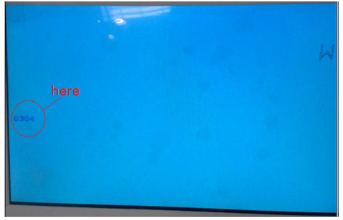
Figure 2-11
Step 6 After changing, press call button again, then reboot the VTH.
If there are more than one VTH, please test them one by one.

- Install lock and unlock button
General types of lock in market are unlocking with power and unlocking without power.
3.1 VTO1210A/VTO1220A/VTO1210A-X(Figure 2-3)
Port 02—access control input port, which connect to signal from the door sensor, door on/off signal.
Port 07—access control output port, which control NO/NC of door lock.
Here make electric lock as example.When connect VTO to electric lock, make electric lock + toward VTO NO-end (03.3-pin 1) and electric – toward VTO COM-end. See Figure 3-1.

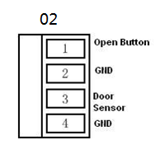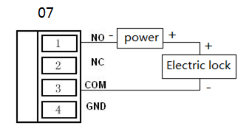

Figure 3-1
3.2 VTO1210B-X（Figure 2-6）
Port 03—access control input port, which connect to signal from the door sensor, door on/off signal.
Port 05—access control output port, which control NO/NC of door lock.
Here make electric lock as example.When connect VTO to electric lock, make electric lock + toward VTO NO-end (03.3-pin 1) and electric – toward VTO COM-end. See Figure 3-2
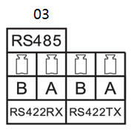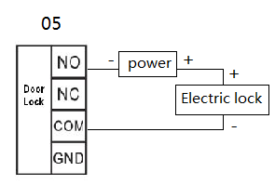
Figure 3-2

- Issue Card by password
The device supports IC card with frequency 13.56MHz.

Step1 Input the #888888# log on the project setting of the outdoor station
Step2 Choose issue card, press * log on.
Step3 Choose password issue card.
Step4 Input the password:002236
Step5 Input the room NO for the card, and put the card on the card reading area.
Step6 After issuing card, press * to exit.

