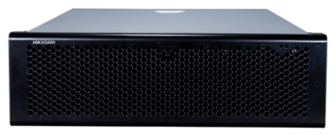DS-A81016S
Network Storage Device

Introduction:  As the cost-effective network storage device, Hikvision DS-A81016S is developed on the controller architecture and adopts multiple advanced technologies, including video streaming technology, RAID technology, intelligent technology, etc. It is integrated with camera management, video storage, live view, search, playback, download and other functionalities. With this product, you can build a small-scale video management platform independently, or establish a medium/large-scale video management system incorporation with the supporting service platform.  Thanks to these features, DS-A81016S is widely applied to the security surveillance projects of the bank, school, store, enterprise, hotel, etc.  Available Model:  DS-A81016S  Main Features:  - 64-bit embedded multi-core processor with 4GB high-speed buffer; 6Gbps SAS transmission; SBB2.0 technology  - Connectable to encoding devices (IPC/DVR/encoder/NVR) using standard stream media protocol such as RTSP, ONVIF, PISIA, etc.; Connectable to encoding devices from third-party manufacturers such as AXIS, PELCO, Bosch, Canon, ,Panasonic, SAMSUNG, SONY, etc.  - Support 240-ch 2Mbps concurrent writing; 16-ch synchronous playback  - Integrated with CVR/IP SAN/NAS application service  - Support built-in stream media module to forward real-time video stream  - Up to 16 SATA hard disks (hot swap) can be installed; Up to 64TB capacity is supported for each device and 2-level expansion cabinets can be cascade connected; Up to 192TB capacity supported for each system  - Support RAID 0, 1, 3, 5, 6, 10, 50, JBOD, hot spare  - Support multiple recording types, including continuous recording, manual recording, main and sub stream recording; motion recording, sensor alarm recording, video loss alarm recording, etc.  - Search, play back, download record files by type or time  - User friendly B/S or C/S interface supporting one-touch quick setting  - Multiple alarm linkage actions such as acousto-optic, text message, email  - Download device logs to USB flash drive automatically  - 2 Gigabit Ethernet ports supporting network interface bonding  - Support N+1 hot spare system  - Automatic Network Replenishment (ANR) ensuring data integrity  - Data backup increasing data security  - Lock and archive the key video file for protection |  | Physical Interfaces:  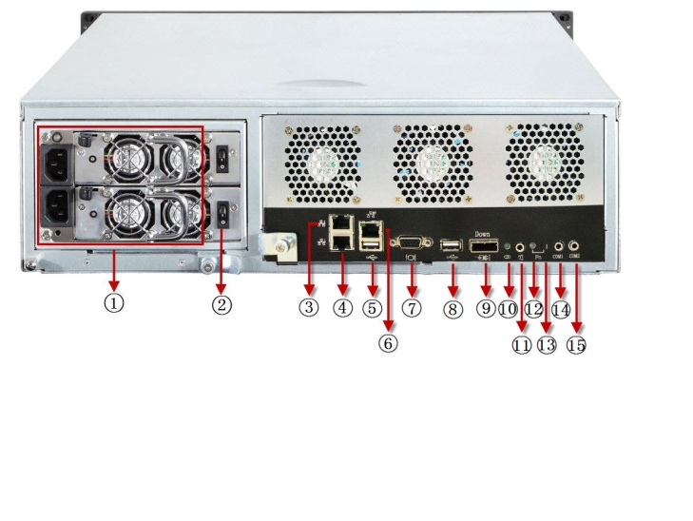  9: Expansion Port  10: Expansion Port Indicator  11: Audio Out  12: FN Device Positioning Indicator  13: FN Device Positioning Button  14: COM1: Hyper Terminal  15: COM2: Mobile Phone Alarm/UPS  1: Power Supply  2: Power Switch  3: Data Port 2  4: Data Port 1  5: USB Interface  6: Management Port  7: VGA Output  8: USB Interface  Typical Application:  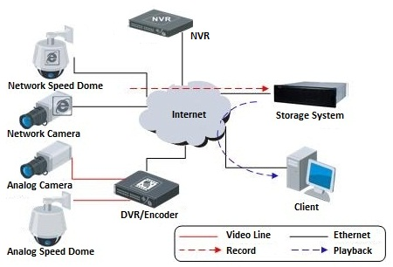  Performance Index:
  Mode  Resolution | IP SAN | CVR
  D1 (2Mbps) Record + Playback | 180-ch | 256-ch
Specifications:
Model | DS-A81016S
Controller | Processor | 64-bit multi-core processor
Controller | High-speed buffer | 4GB (expandable to 8G)
Video/Audio input and output | Record + Playback | 256-ch (2Mps)
General | Operating system | Windows, Linux, Solaris, HP-UX, AIX, MacOS
General | HDD slot | 16
General | HDD interface | SATA /1TB, 2TB, 3TB, 4TB
General | Hot-swap disk | Supported
General | RAID level | RAID 0, 1, 3, 5, 6, 10, 50, JBOD, hot spare
Storage management | Disk management | S.M.A.R.T. ((Self-Monitoring, Analysis and Reporting Technology)
Storage management | LUN management | NAS Volume, iSCSI Volume, Record Volume
Storage management | Data protection | WORM tamper-proof, Real-time backup of system information, LUN clone
Record management | Recording type | Continuous / Manual / Main and Sub Stream / Motion / Sensor, etc.
Record management | Recording backup | Local backup; Remote backup
Record management | Recording protection | Lock key video file for protection, N+1 hot spare system, ANR, video loss alarm
Record management | Search mode | By time / type
Record management | Download mode | Quick download, batch download, segment download, merging download
Device management | Management method | Web-based GUI, CLI serial port, integrated management of multiple units
Device management | Alarm type | Sound, Flash LED, Email, SMS, Warning on device management page
Device management | Log download | Auto-download by USB flash drive, Remote backup via web browsing
Network | Protocol | RTSP / ONVIF / PSIA / iSCSI / NFS / CIFS / FTP / HTTP / AFP
External port | Data port | 2 (can be expanded to 6), 10M/100M/1000M self-adaptive Ethernet interface
External port | Management port | 1, 10M/100M/1000M self-adaptive Ethernet interface
External port | SAS expansion port | 1 (6Gbps)
External port | VGA output | 1
External port | COM interface | 2 (1 for hyper terminal and 1 for mobile phone alarm / UPS)
External port | USB interface | 2
Others | Power supply | Redundant (1+1); single power available
Others | Power consumption | Max.460W (with hard disk, redundant power);  Max.400W(with hard disk, single power)
Others | Temperature | Operating: 5℃-40℃; Storage: -20℃-70℃
Others | Humidity | Operating: 20%-80% RH( non-freezing, non-condensing);  Storage: 5%-90% RH( non-freezing, non-condensing)
Others | Chassis | Standard 19-inch rack-mounted 3U chassis
Others | Dimensions (W×H×D) | 440×132×480mm
Others | Weight | Approx.20Kg (without hard disk, redundant power);  Approx.18.5Kg (without hard disk, single power)

